FYI FYI FYI FYI

F O R Y O U R I N F O R M A T I O N
 | Issue | 04-41 | Date: | 12/04
CAREGIVER’S CHOICE ON CONDUCTING AN ADOPTION
HOME STUDY ASSESSMENT

This is to advise staff that caregivers who are adopting children in their care can choose who will conduct their adoptive home study. They may choose either the Department of Children and Family Services (DCFS) or a private, licensed adoption agency (Private Agency). In addition to being licensed to certify caregivers as foster parents, some Foster Family Agencies (FFA) are dually licensed as a foster care facility and adoption agency. A current list of dually licensed FFAs is attached.

Caregiver Expresses a Preference

As part of Concurrent Planning, the case-carrying CSW should inform the caregiver that DCFS will develop a backup or alternate permanency plan in case the child is not reunified with his/her parents. As part of the permanency discussion, the case-carrying CSW shall present to the caregiver the various permanency planning options and ask him or her if they would like to be considered as a permanency option for the child(ren). It is during these discussions that a caregiver may express their desire to have their adoptive home study completed by DCFS or a FFA, the one certifying them as foster parents or another Private Agency of their choice.

Caregiver Does Not Express a Preference

If the caregiver does not express a preference then, generally, DCFS will be assigned to conduct the adoptive home study for caregivers who are County licensed foster parents and dually licensed agencies will be assigned to conduct the adoptive home study for families they have certified as foster parents. If the caregiver, who does not express a preference, is a certified foster parent by a FFA that is not dually licensed to conduct adoption home studies, DCFS will generally be assigned to conduct the adoptive home study. Also, DCFS will generally be assigned to conduct the adoptive home study of relative caregivers, unless they express a preference for a Private Agency.

 |  | If you have any questions regarding this release please  e-mail your question to:  Policy@dcfs.co.la.ca.us
Clerical Handbook: http://198.51.213.151/Policy/Hndbook%20Clerical/Default.htm
Child Welfare Services Handbook: http://198.51.213.151/Policy/Hndbook%20CWS/default.htm
FYI’s: http://198.51.213.151/Policy/FYI/TOCFYI.htm

How Does the Adoption Home Study Get Assigned

The CSW should follow current policy (Procedural Guide 0080-507.20 Concurrent Planning: Completing the Permanency Planning/Adoption Assessment and Activating the Permanence Track) to activate the adoption home study assessment.

The Concurrent Planning Permanency Planning Adoption Assessment (CP PP AA) is the current tool used to activate and assign an adoption home study. Section IX-Placement/Funding Information of the CP PP AA requests the case carrying CSW to indicate the type of placement, Relative, County Foster Care or FFA, along with the name of the FFA. As well, the caregivers stated preference, if any should be written in Section IX of the CP PP AA, including the name of the agency they prefer, DCFS or FFA. The assigning clerk will review this section to ascertain the type of placement and assign the adoption home study using the criteria identified above. The Adoption SCSW checks CWS/CMS and AIS, or assigns the CSW or unit clerk to do so, to see if a family already has completed a home study.

Assignment on CWS/CMS

If DCFS is designated to conduct the adoption home study, the assigned adoption CSW will be added as a secondary on the case in CWS/CMS. If a Private Agency is designated to conduct the adoption home study, the agency name will be added as a secondary on the case in CWS/CMS.

When a Private Agency is assigned to conduct the adoption home study, a DCFS Adoption CSW (A-CSW) will also be assigned as a secondary on CWS/CMS in addition to the Private Agency. The role of the A-CSW will be to liaison and consult with the regional CSW and Private Agency as necessary in regards to adoption and court issues, as well as, review the completed adoption home study with their SCSW for completeness and address any concerns with the private agency. A letter detailing the role of the A-CSW is sent to the A-CSW when they are assigned the case. A sample of the letter is attached.

In addition to creating the assignment on CWS/CMS, assignments will be created on Adoption Information System (AIS). The AIS User Guide is attached.

Notification to Case Carrying CSW who is Assigned to Conduct Adoption Home Study

The assigning clerk will send an e-mail notification to the regional CSW with the name of who is assigned to conduct the adoption home study. This e-mail will be copied to the regional CSW’s supervisor and the A-CSW assigned to the case. A sample is attached.

Private Agency Inadvertently Not Assigned to Conduct Adoption Home Study

If inadvertently a Private Agency is not assigned to complete the adoptive home study, the A-CSW should request their SCSW assign the case to the Private Agency.

If the regional CSW or A-CSW is notified by a Private Agency that the caregiver prefers they complete the adoption home study, the A-CSW should confer and confirm with the caregiver, prior to assigning the Private Agency to complete the home study. The regional CSW and A-CSW should confer prior to making this change. To assign the home study to the private agency the A-CSW should request their SCSW assign the case to the Private Agency.

Fast Track to Permanency Cases (FTP)

Children who meet (FTP) criteria should be initially placed at detention through DCFS Placement and Recruitment Unit (PRU). For children who meet FTP criteria, staff should contact the Adoptions Division Placement and Recruitment Unit by calling 1-800-811-1121 ext. 2 for placement resources, unless relatives or sibling placement options exist for these children. PRU will find a placement with an approved and waiting prospective adoptive family, either DCFS or Private Agency approved.

Additionally, if a child who meets FTP criteria is not placed with relatives and or with siblings who are already placed in out-of-home care, regardless as to whether the sibling has been adopted or the sibling does not currently have an existing relationship staff should call PRU for placement with an approved and waiting prospective adoptive family. In addition, if child is not placed in a foster home also approved for adoption, staff should call PRU for placement with an approved and waiting prospective adoptive family, if the child was placed less then two months with the current foster parent. Placing the child with an approved prospective adoptive family will insure timely permanence and adoption for this child when parental rights are terminated.

PERMANENCY PARTNERSHIPS FOR CHILDREN
Foster Family Agencies Dually Licensed to Provide Adoption Services

As of 09/15/2004
Private Agency  Name and Address | Executive Director | Phone/Fax nos. | Representatives | Phone/Fax nos.
*  Institute for Black Parenting  1299 E. Artesia Blvd., Suite. 200  Carson, CA 90746 | Zena Oglesby | Phone: (310) 900-0930 ext. 211  Fax: (310) 900-0949 | Alondra James  Supervisor Finalization  Felice Bondon, Adoption Supervisor  Cynthia Willard, Asst. Exec. Director  Debra Benjamin, Program Director | Ajames@blackparenting.org  Phone: (310) 900-0932 ext. 212  Phone: (310) 900-0932 ext. 238  Phone: (310) 900-0930 ext. 229  Fax: (310) 900-0949  Fbondon@blackparenting.org
*  Children’s Bureau  11815 Riverside Drive  North Hollywood, CA 91607 | Alex Morales | Phone: (323) 644-3900  Fax: (323)644-3907 | Jan Austin  Lou Graham  Cathy Allen  Cynthia Stogel  Lisa Salinas, Finalization | Jaustin@all4kids.org  lgraham@all4kids.org  Phone: (818) 985-8154 ext. 207  Fax: (818) 985-7045  Phone: (818) 985-8154 ext. 202  cstogel@all4kids.org  lsalinas@all4kids.com
*  Vista Del Mar Children & Family Services  3200 Motor Avenue  Los Angeles, CA 90034 | Gerald Zaslaw, President | Phone: (310) 836-1223  Fax: (310) 836-3863 | Rhona Gardner  Linda Lipscomb | Phone: (310) 836-1223 ext. 288  Fax: (310) 836-3863  Rgardner@vistadelmar.org  Linda1546@aol.com  818-353-9507
*  Holy Family Services  402 S. Marengo Avenue  Pasadena, CA 91101-3113 | Debra Richardson | Phone: (626) 432-5680  Fax: (626) 578-7321 | Larry Lauber  Intake Coordinator | Phone: (626) 432-5680 ext. 13  Fax: (626) 578-7321  Larryhfs@pacbell.net
*  Westside Children’s Center  12120 Wagner Street  Culver City, CA. 90230 | Gaylynn Thomas, Director of Social Services | Phone: (310) 390-0551  Fax: (310) 397-2213 | Laurie Rein  Jessica Cienfuegos, Finalization Clerk | Laurao@westsidechildrens.org  Phone: (310) 390-0551  Fax: (310) 397-2213  Laurier@westsidechildrens.org  Jessicac@westsidechildrens.org
*  Olive Crest  2130 East Fourth Street, Suite 200  Santa Ana, CA 92705  710 S. Victory Blvd., Suite 201  Burbank, CA 91502 | Kerri Dunkelberger, Executive Director | Phone: (714) 543-5437  ext. 1119  Fax: (714) 543-5463 | Carolee Darden  (Santa Ana)  Sharon Kim | Phone: (714)543-5437 ext 1185  Fax: (714) 543-5463  Phone: (818) 563-2300 ext. 1319  Fax: (818) 563-2342
Latino Family Institute, Inc.  1501 W. Cameron Ave., Suite. 240  West Covina, CA 91790 | Maria Quintanilla, LCSW | Phone: (626) 472-0123  Ext. 208  (800) 294-9161  Fax: (626) 337-8752 | Gavriela Trujillo (Intern) | Phone: (626) 472-0123  Fax: (626) 337-8752  Latinofamilyinstituteinc@yahoo.com
*  Southern California Foster Family and Adoption Agency  155 N. Occidental Boulevard  Los Angeles, CA 90026 | Sylvia Fogelman | Phone: (213) 365-2900  Fax: (213) 365-0228 | Robyn Harrod | Phone: (213) 365-2900  Fax: (213) 365-0228  Robynlharrod90035@yahoo.com
The Sycamores  625 Fair Oaks Avenue, Suite 300  South Pasadena, CA 91030 | Bill Martone, | Phone: (626) 395-7100  Fax: (626) 799-4596 | Litsa Mitchell, Director of FFA & Adoptions  Beth Gallegos | Phone: (626) 395-7100 ext. 2750  Fax: (626) 799-4596  (626) 395-7100 ext. 4505  e mail: litsa@Sycamores.org  bethgallegos@Sycamores.org
Inner Circle  7120 Havenhurst Avenue, Ste. 204  Van Nuys, CA 91406 | Gary Dennis | Phone: (818) 988-6300  Fax: (818) 988-7087 | Jill Rosenberg  Amy Wong-Martinez, (Adoption Supervisor) | Phone: (818) 988-6300 ext. 14  Fax: (818) 988-7087  Jillr@fosterfamily.org
Optimist Foster Family Agency  7330 N. Figueroa St.  L. A. CA 90041 | Joan Probst  Linda Lipscomb  Coordinator  P.O. Box 279  Sunland, CA 91041-0279 | Linda1546@aol.com  Phone: (818) 353-9507  Fax: (same as above) | Kim Sutton  Ksutton@oyhfs.org | Phone: (323) 341-5561 ext. 205  Phone: (323) 341-5561  Fax: (323) 257-6418
Five Acres  898 N. Fair Oaks Avenue, Suite H  Pasadena, CA 91103 | Robert Ketch | Phone: (626) 798-6793  Fax: (626) 585-1664 | Patricia Old, (Dir of Foster Care & Adopt)  Marianne Guilfoyle (FC therapist) | Phone: (626) 844-1430 ext. 208  Fax: (626) 585-1664  Pold@5acres.org  Mguilfoyle@5acres.org
McKinley Family Foster Agency  762 West Cypress Street  San Dimas, CA 91733-3599 | Pamela Jordan |  | Toni Bell | Phone: (909) 599-1227 ext. 2803  Fax: (909) 599-2817  Jordanp@McKinley.org
Excell Family Intervention Program  8616 La Tijera Blvd., #412  Los Angeles, CA 90045 | Lilian Tennell | (310) 337-7053 | Magaly Lee | Mlee103@pacbell.net  Phone: (310) 337-7053  Fax #: (310) 337-2780
Families For Children/Adopt A Child  2500 W. Manchester Blvd.  Inglewood, CA 90305 | Andrew Henderson, |  | Renee White, Adoption Specialist | Andrew@familiesforchildren.org  Phone: (323) 750-5855 ext. 101  Phone: (323) 750-5855 ext. 104  Fax: (323) 750-5885
Penny Lane  9140 Van Nuys Blvd., Ste. 108  Panorama city, CA 91402 | Judith Sandino |  | Gail Moore | Phone: (818) 894-3384 ext. 282  Fax: (818) 895-5186  Gmoore@pennylane.org
Aspira Adoption Program  119 Figueroa Street  Ventura, CA 93001 | Vernon Brown, CEO |  | Kara Maruoka-Lynn  So Cal Regional Supervisor | Phone: (805) 648-5558  Fax: (805) 648-4668
Hannah’s FFA  1045 W. Katella Ave., Ste. 330  Orange, CA 92867 | Kimberly Berry  Connie Frank |  | Helen Lindsey | Phone: (714) 516-1083  (714) 516-1077  Fax: (714) 516-1079
Wings of Refuge  5777 W Century Blvd.  Suite 900  Los Angeles, CA 90045 | Cristi Chastain | (310) 670-6767 | Cristi Chastain | Phone: (310) 670-6767  Fax: (310) 670-2626  Cchastain@wingsofrefuge.org
*Agencies Licensed and with the project since April, 1999

DEPARTMENT OF CHILDREN AND FAMILY SERVICES
SERVICES BUREAU 4 – ADOPTIONS DIVISION
________________________________________________________________

To: Adoption CSW

From: Case Assignment Desk

PRIVATE ADOPTION AGENCY HOME STUDY ASSIGNMENT

INSTRUCTIONS

Enclosed please find an applicant case for the following home study that has been referred to a private agency.

Applicant(s):

Child(ren):

Agency and Contact:

Although the home study will be completed by the private agency, you are receiving “A” case credit of .625 for this case and will be assigned as a secondary Adoption worker on CWS/CMS. Your role is to consult with the regional CSW and private agency as necessary in regards to adoption and court issues. Upon completion of the home study by the private agency, you and your supervisor will review the home study narrative and supporting documents for completeness and address any concerns with the private agency. Sometimes at the .26 hearing, the Court will require documentation from DCFS that the home study completed by the private agency has been reviewed and accepted by DCFS, so that concerns regarding the home study will not delay the adoption.

Once the child is legally freed and the child’s case is transferred from the region, you will become the primary CSW assigned and your secondary assignment will be end dated. You will no longer receive credit for the applicant case as your role with the case in that capacity has been completed. The adoptive placement will be a cooperative placement and you will continue to work with the private agency per following protocols until the adoption is finalized.

Adoptive Placement
- After receipt of the Acknowledgement and approved and reviewed home study, please proceed with scheduling a joint appointment to sign adoptive placement papers with the private agency home study worker and the applicants. DCFS-Adoption CSWs are responsible for the placement paperwork.

- Be prepared to provide the Private Agency Adoption Home Study Worker with a copy of the following paperwork provided to the Adoptive Parent you sign adoptive placement paperwork:
- AD 559 – Notice of Placement
- AD 67A & 67B
- AD 512

Post-Placement Supervision, Proceeding with Finalization and Kinship Adoption Agreements
The private adoption agency is responsible for providing post-placement adoption supervision and finalization services. Please remember that as the DCFS CSW, you remain responsible for all child-welfare-related services, including visitation.

The private agency will send you a “Post Placement Supervision Report. This form provides you with several important pieces of information in addition to acting as a notice to prepare the case for finalization, as indicated next:
- It informs you that the private agency has conducted the required post-placement supervision and recommends proceeding with finalization.
- It lets you know if there are any concerns and recommends a case plan. Be sure to follow up with the private agency worker and/or family to be involved in the plan.
- It lets you know if this case will involve a Kinship Adoption and provides you with a copy of the agreement, for your review and approval. Remember that DCFS Adoption CSWs must address the kinship agreement in the final court report, if applicable.
- It informs you about the adoptive parent(s) plans for proceeding with finalization –specifically you will be told if the family plans to hire their own attorney, go through the DCFS Finalization Project for legal representation or finalize their adoption some other way.
- It requests you process the case for completions and provide the agency with the necessary paperwork.

Upon receipt of the Post Placement Supervision Report that recommends proceeding with finalization, please do the following:

- Process the DCFS/A 137, Request For Reduction in Post-Placement Supervision
- Process the case for completions and have case to your completions clerk within 10 days of receipt of this notice. Please see the “Completions Checklist” as to the items required for putting the cooperative placement into completions.

Finalization, Termination of Jurisdiction, Case Closure and Processing of Non-Recurring Adoption Expenses

The private agency will be responsible for finalization. They will notify you by phone of the finalization date. Please track this date and work with the private agency so that you can obtain the Adoption Decree/Order of Adoption immediately following finalization in order to terminate jurisdiction (JT) and to close services.

Non-Recurring Adoption Expense claims are processed through the Adoption Assistants per the regular procedures.

Please address any questions through your chain of command.

User Guide

AIS

A-Case

Assignments

Topics include:
AIS Login
Making Assignments
Ending Assignments

The enclosed/attached information provided to you is confidential pursuant to the California Welfare and Institutions Code ("WIC") and Family Code ("FC"). It is confidential under both state and federal law and may be shared only with DCFS staff. It may not be copied, shared or distributed in a manner inconsistent with WIC and the FC.
Step 1
Step 1

1

AIS is Accessed via LA Kids

Step 2
Open LA Kids and
select Web
Applications.

Step 2

The Web Applications
window will appear.
Select Adoption
Integrated System
(AIS)

LogIn and open Applicant Openings module
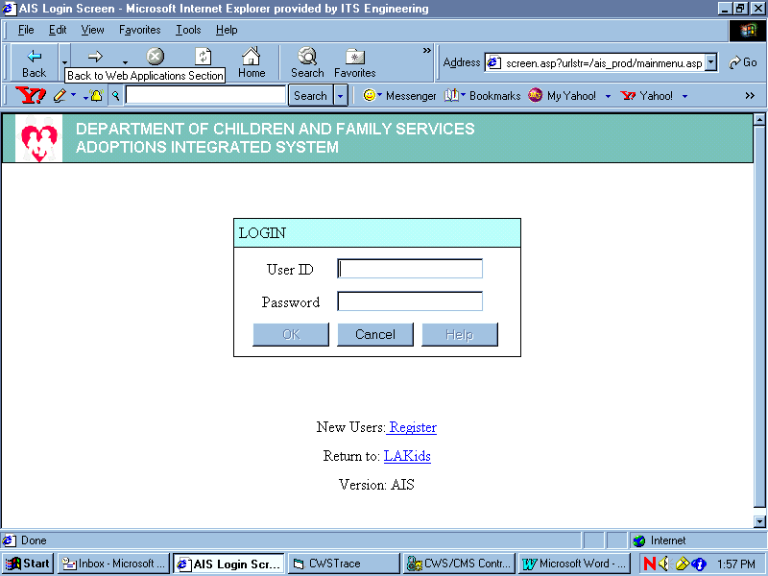
Step 1

Login.

If you are a new user, click
Step 1
on the Register link. Print
out and complete the
resulting form.
Send completed form to the
Adoptions CAO.

The initial login User ID is
your CWS/CMS ID found
when you open CWS/CMS.

The initial password is
“changeme”. During the
initial login, you will be asked
to change your password
from “changeme” to a
password of your choice.
Then save. If you
need further assistance,
please refer to the login
Step 2
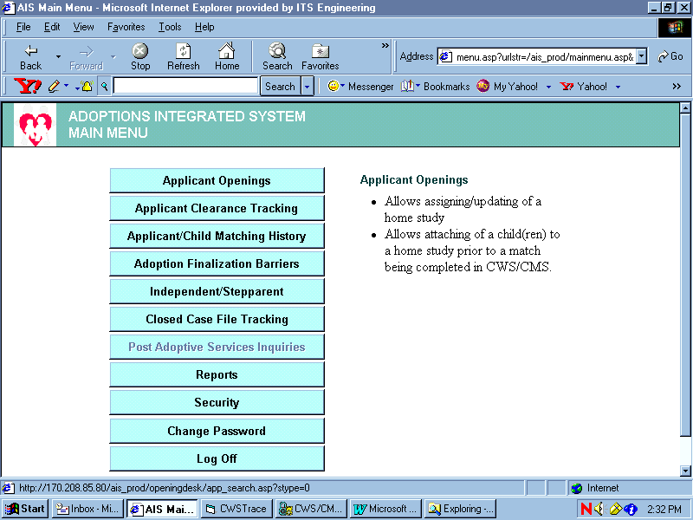
guide.

Step 2

Select Applicant
Openings.

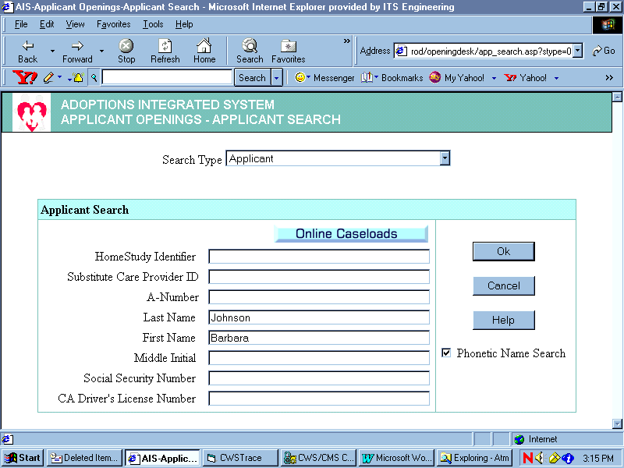
Step 1

Search for A-Case

Enter Search Criteria: this
will usually be done using
one of the applicant’s last
names and first names.
Other formats are
suggested
Step 1
below.

Step 2
Step 2

Click OK

Optional: Other search criteria formats

The wild card symbol “%” may be used to replace unknown variables. For example, if searching by A# whose format may include “A 123456”, “A-123456”, and “A123456”, simply use “%123456”. Or for the last name of Anderson, or Andersen, or Anderstone, use “Anders%”.

Or addresses may be used though the number of variations of an address is considerable.

Searches by the name of the child the applicant is “attached” to is also available by changing the search type at the top to Attached Child in the drop down box.

Identifying the appropriate case

The next window that
opens will look like this

Step 1

Key information such as
the A-case number, the
address and phone
number can be found by
scrolling to the screen to
the right.
Step 2

Note: each of the cases in
this window were created
and exist in CWS/CMS.
Step 2

Select the most probable
Step 1
home study by clicking
on the number associated
to it.

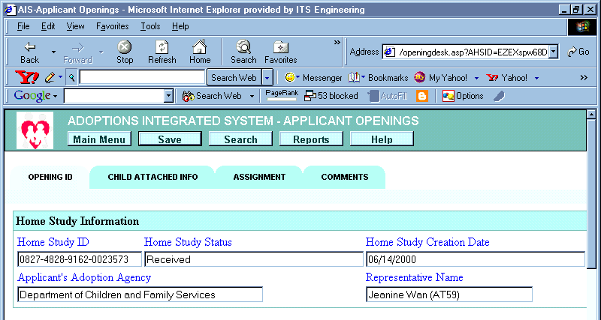
Step 3
Step 3

To further determine is
this is the appropriate
case, the Opening ID
page shows the name of
the CSW initially assigned the case.

Selecting the Child
Attached Info tab will
reveal more information.

If this is the wrong case,
simply click on the Back
button and you will be taken to the screen above.
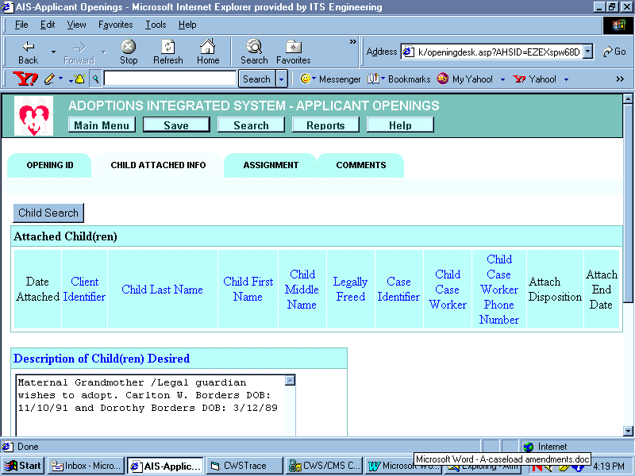

Making the Assignment

Step 1
Step 1

Click on the Child
Attached Info page.
The information in the
Description of
Child(ren)
Desired field may
assist to confirm or
disprove that this is
the correct
case to assign or end
the assignment of.

If this is the wrong
case, simply click on
the Back
button and you will be
taken to the first screen
on the previous page.

Step 2
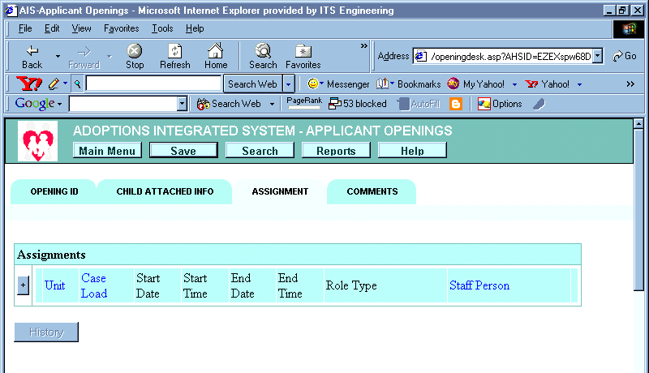

Select the
Assignment tab.
Step 2
Step 3

Click on the “+” button.
Step 3

A new window will pop
up with the current date
Adding Cases (Adding the assignment)
and time.

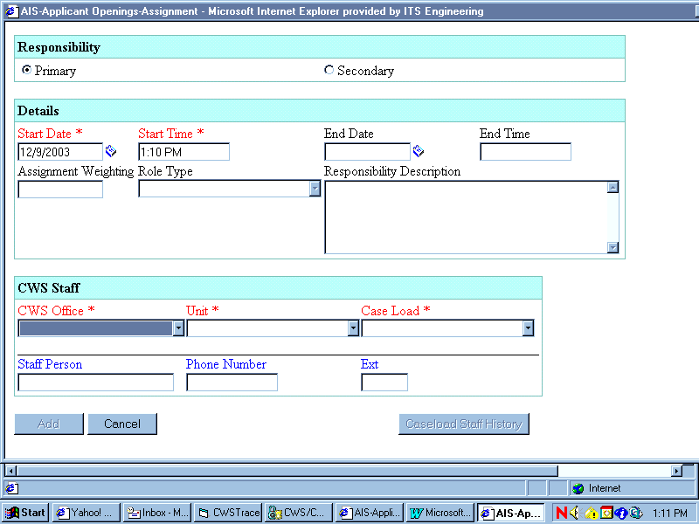
Step 1

Select the appropriate
CWS Office, Unit, and
Case Load from the drop
down menus.

Note: the first four digits
Step 1
of the caseload # is based
upon your file #, and the
last five digits designate
an adoption office
assignment of “S0216”.

Step 2

After completing Step 1, the Add
button will become enabled. Click
Step 2
on Add.
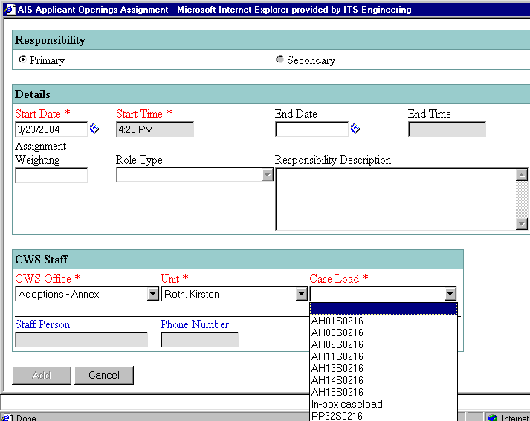
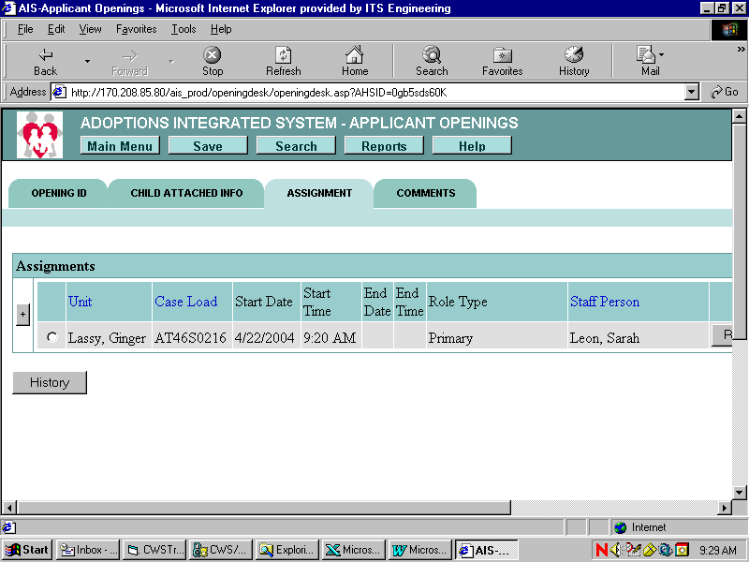
Step 1
Step 2

Assignment for Private Agency Cases
A Primary assignment in AIS should be made to the DCFS CSW responsible for adoption-related casework. After selecting a caseload click the “Add” button.
You will then see the Assignment screen with the CSW name and file number that was assigned. If the information appears correct, click the “Save” button near the top of the screen. Now click the “+” to assign the Private Agency.

Step 3

Assignment for Private Agency Cases

The Private Agency completing the home study is assigned with Secondary responsibility, in AIS.

- Choose Secondary
- In Role Type Choose “Adoptions Worker”
- CWS Office is “Adoptions Headquarters
- Unit is Private Agency
- Choose the Private Agency from the Caseload drop-down

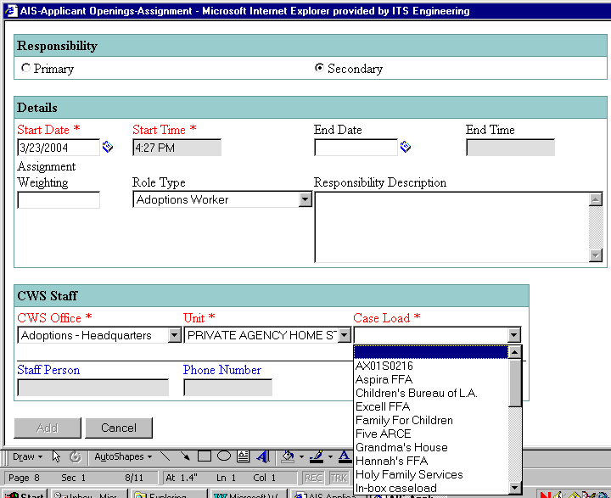
A.
B.
C.
D.
E.

Step 1

Step 2
Review the
assignment.

Step 2
Step 1

Save changes.

The “save” is complete
when the screen
returns to the Opening
ID page.

Done!

If the applicant case could not be found in AIS, it will need to be built in CWS/CMS. Please refer to the User Guide - Opening/Editing A-Cases In CWS/CMS for instructions.

Step 1

Ending Assignments

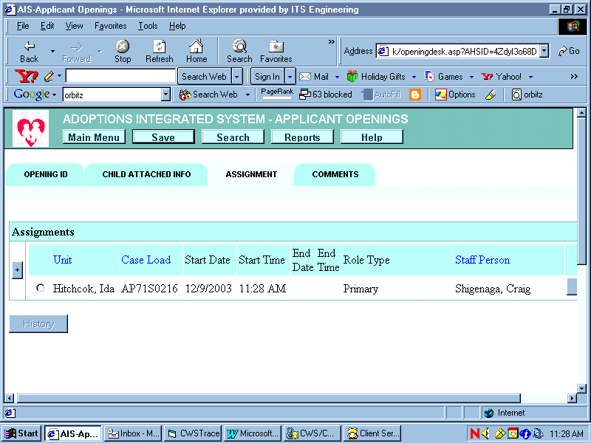
Click on the radial
button. The next
window below will
appear.

Step 1

Step 2

Enter the End Date.
The End Time is
unnecessary.

Step 3

Click on the Update button, and this window will disappear.

The window at right

Ending Assignments
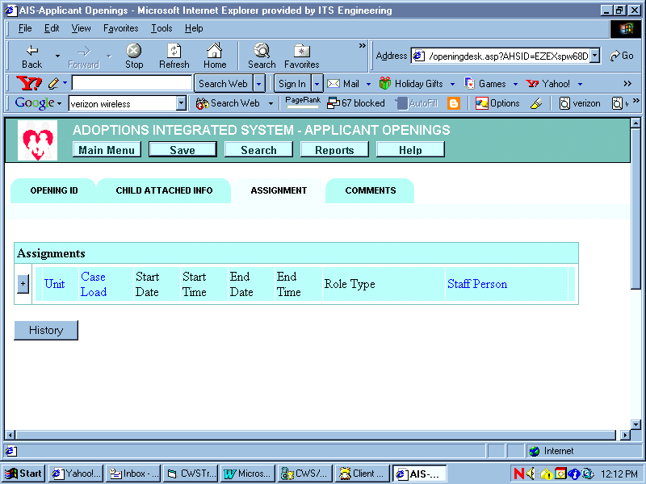
will remain. Because
the assignment is now
ended, the information
is stored in History.

Step 1

Optional: To view
your changes click on
the History button.
Step 1

This page will appear.

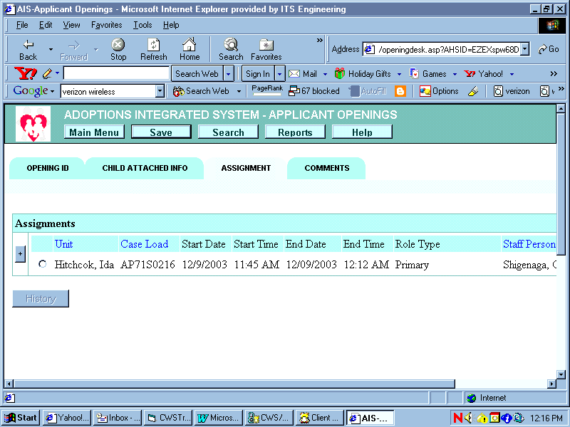
Step 2

Save changes.

The “save” is
Step 2
complete
when the screen
returns to the Opening
ID page.

Done!

 | County of Los Angeles  DEPARTMENT OF CHILDREN AND FAMILY SERVICES  425 Shatto Place, Los Angeles, California 90020  (213) 351-5602
DAVID SANDERS, PH.D.
Board of Supervisors

GLORIA MOLINA
First District
YVONNE BRATHWAITE BURKE
Second District

ZEV YAROSLAVSKY
Third District
DON KNABE
Fourth District

MICHAEL D. ANTONOVICH
Fifth District

Director

, 200

To: , CSW

From: , SCSW

ASSIGNMENT OF ADOPTION CSW TO CONDUCT HOMESTUDY OF FAMILY ON BEHALF OF THE CHILD(REN)

Adoption CSW, , has been assigned to conduct the Adoption Home study of . has been assigned secondary status on CWS/CMS and should be calling you soon to introduce themselves and begin collaboration on the case. Your experience and knowledge of this case is invaluable. Please share with any strengths or areas of concern you may have about the family providing a permanent home for .

, Adoption CSW will be contacting the family to introduce themselves and initiate the adoption home study process. Hopefully, you will both be able to able to schedule a mutually convenient, joint home visit as specified in the TPR Protocol.

will provide you with feedback in regard to their assessment and the likelihood that the adoption home study will be approved. These updates will be provided on going but with particular consideration to court hearing dates.

can be reached at ( ) and I can be reached at ( ) . We look forward to working together as a team to provide a safe, loving, permanent home for .

cc: , SCSW
, A-CSW

