FYI FYI FYI FYI

F O R Y O U R I N F O R M A T I O N
 | Issue | 09-07 | Date: | 02/11/09
REQUESTING COPIES OF FAMILY ASSESSMENTS/HOME STUDIES
FROM FOSTER FAMILY/ADOPTION AGENCIES (DUALLY LICENSED AGENCIES)

California adoption regulations state that a Family Assessment (Adoption Home Study) is a confidential document that is to be maintained in a locked area by the adoption agency that conducted the assessment. (See CDSS’s Manual of Policies and Procedures - Adoption User’s Manual section 89131) When appropriate and necessary, the document may be shared with another adoption agency but confidentiality of identifying information regarding the applicants must be maintained by the receiving adoption agency, (California Family Code 9201). Only the assigned adoption CSW, as a representative of the Adoption and Permanency Resources Division (APRD) (the DCFS licensed adoption agency), is to request a copy of a Family Assessment from APRD Placement and Recruitment Unit (PRU) or from a dually-licensed private agency. Due to these State adoption confidentiality requirements, the written family assessments cannot be given to regional CSWs or the Court and must be maintained with the assigned adoption CSW.

While care must be exercised to avoid giving identifying birth family information to adoptive families, and vice versa, much of the non-identifying information within the assessment/homestudy can and should be verbally shared with other team members in coordinating concurrent planning efforts for a child. The adoption CSW is to make all pertinent, non-identifying information about the potential adoptive family available to the team to ensure everyone is well informed so a solid decision can be reached. The A-CSW should exercise caution in not revealing sensitive personal information that the family may not want shared (without permission or waiver from the family) in discussions with non-adoption staff or written Court reports. If there are concerns about what can and should be shared, please consult with County Counsel.

It is the role of the adoption CSW under Concurrent Planning Redesign (CPR) to work collaboratively with their regional partners, the child and the child’s caregivers to ensure that the family which can best meet the child’s needs for permanence is identified. For all unattached children, upon assignment, the adoption CSW will work actively with PRU to identify a prospective adoptive family and keep the team apprised of progress toward that goal. There are children who were referred to PRU prior to the full implementation of CPR. If an adoption CSW is not yet assigned to a child in PRU, one may be assigned by updating the CPA which can trigger the assignment process [see Procedural Guide 0080-507.20 Concurrent Planning and the Concurrent Planning Assessment (CPA)].

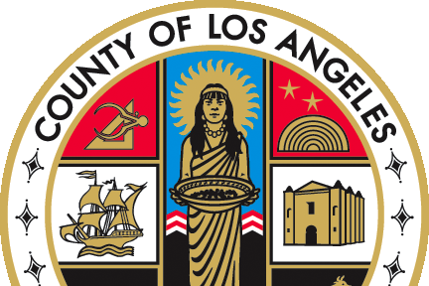   |  | If you have any questions regarding this release please  e-mail your question to:  Policy@dcfs.lacounty.gov |
Clerical Handbook: http://lacdcfs.org/Policy/Hndbook%20Clerical/Default.htm
Child Welfare Services Handbook: http://lacdcfs.org/Policy/Hndbook%20CWS/default.htm
FYI’s: http://lacdcfs.org/Policy/FYI/TOCFYI.htm

