FYI FYI FYI FYI

F O R Y O U R I N F O R M A T I O N
 | Issue | 09-19 | Date: | 04/22/09
FORMS POSTING UPDATE

This is to provide staff with an update to the posting of new/revised forms to LA Kids and to the CWS/CMS (LA County specific templates) since the release of FYI 09-14, issued 03/25/09:

Posting to LA Kids Forms Page

DCFS 64C, Bus Coupon Reconciliation Report
DCFS 64P, Bus Pass Reconciliation Report
DCFS 64T, Bus Token Reconciliation Report
DCFS 74A, Interpreter Usage and Consent for Release of Information
DCFS 292-1, Cash Aid Check Transmittal
DCFS 1360, Mentoring Program Referral Form,
DCFS 4213, Special Placements Form
DCFS 5555, Kinship Guardianship Assistance Payment (KIN-GAP) Fact Sheet
DCFS 5600, Live-Scan Criminal History Request
DCFS 5600-A, Criminal History CLETS / NCIC III Request
DCFS/A 402, Negotiated Adoption Assistance Program Benefit Agreement
DCFS/A 402, Negotiated Adoption Assistance Program Benefit Agreement (SP)
BCII 8302, No Longer Interested (NLI) Notification
JV 184, Order After Hearing on Form JV-180, Request to Change Court Order
JV 219, Information About Psychotropic Medication Forms
Self-Directed Training Fund Request

CWS/CMS (LA County specific templates)

DCFS 4157, Psychotropic Medication Progress Report (Follow-up Questionnaire)
DCFS 5600, Live-Scan Criminal History Request
DCFS 5600-A, Criminal History CLETS / NCIC III Request

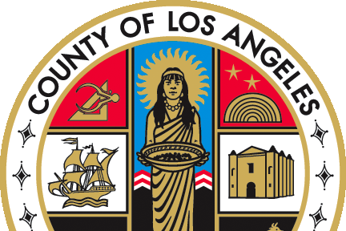   |  | If you have any questions regarding this release please  e-mail your question to:  Policy@dcfs.lacounty.gov |
Clerical Handbook: http://lacdcfs.org/Policy/Hndbook%20Clerical/Default.htm
Child Welfare Services Handbook: http://lacdcfs.org/Policy/Hndbook%20CWS/default.htm
FYI’s: http://lacdcfs.org/Policy/FYI/TOCFYI.htm

