FYI FYI FYI FYI

F O R Y O U R I N F O R M A T I O N
 | Issue | 09-32 | Date: | 06/29/09
PROVIDING A BIRTH CERTIFICATE TO YOUTH AND LEGAL GUARDIANS

This is to remind staff that to support the Department’s efforts to improve timelines to permanency, CSWs must obtain the child’s birth certificate as early as possible. Procedural Guide 1200-500.10, Vital Records (Birth, Death, Marriage and Divorce) sets forth the procedures to request the birth certificate and/or to register the birth of a child, if necessary. In addition, pursuant to WIC 391 a transitioning youth must be provided with a certified birth certificate before terminating court jurisdiction. See Procedural Guide 0100-535.60, Youth Development: Transitioning to Independence, for more information.
Further, effective immediately, a certified birth certificate, must be provided to the youth and/or the legal guardian (Kin-GAP and non-related) before closing the case. In addition, this action must be documented in the Contact Notebook. Providing a certified copy of a birth certificate to the youth and/or legal guardian would allow and/or facilitate access to services by the youth and/or legal guardian. Further, it will help the youth to live independently, especially after DCFS supervision has ended.

Procedural Guides 0080-502.25, Assessment Process to Terminate Child Welfare Services; 0100-535.60, Youth Development: Transitioning to Independence; 0100-520.35, Kinship Guardianship Assistance Payment (Kin-GAP) Program; and 1200-500.10, Vital Records (Birth, Death, Marriage and Divorce) have been revised to reflect the above instructions.

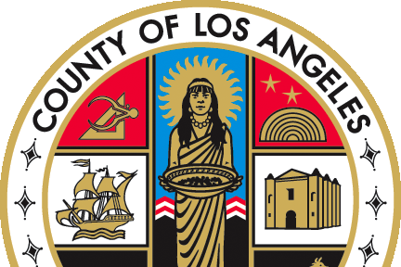   |  | If you have any questions regarding this release please  e-mail your question to:  Policy@dcfs.lacounty.gov |
Clerical Handbook: http://lacdcfs.org/Policy/Hndbook%20Clerical/Default.htm
Child Welfare Services Handbook: http://lacdcfs.org/Policy/Hndbook%20CWS/default.htm
FYI’s: http://lacdcfs.org/Policy/FYI/TOCFYI.htm

