Creating a Child Support Referral Online in IFS

- Login to IFS

The following are steps to login to IFS:

Step 1: To access IFS from LAKids click on Web Applications under either Contents or Quick Links.
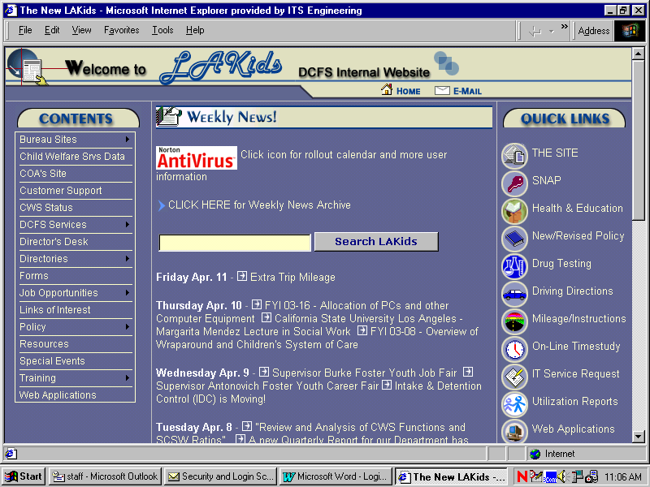

Step 2: Click on the Integrated Financial System (IFS) link.

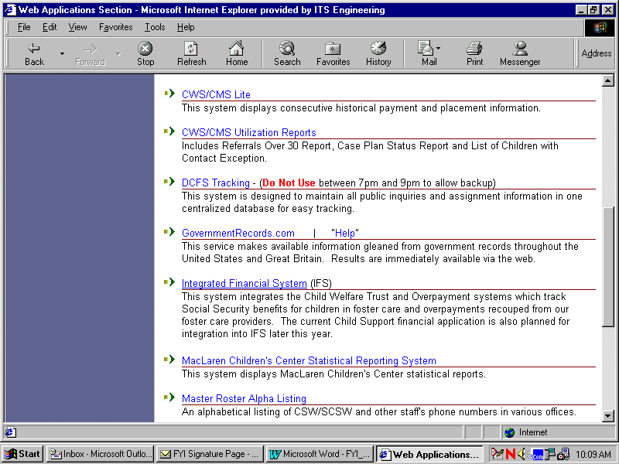

Step 3: To login to IFS users will enter User ID and Password and click on OK button

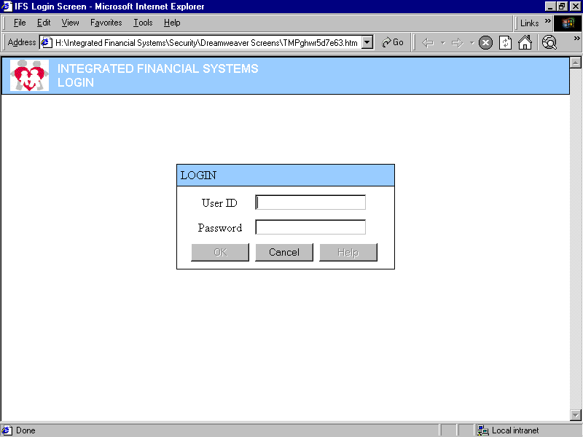
Note: If entering in to IFS for the first time, use “ i7strtr” as the default password. Otherwise, use the password that you created.

II. Creating a online Child Support Referral (CW 2.1 form)

The following are steps for completing a Child Support referral:

Step 1. From the Child Support Menu click on the Referral button.

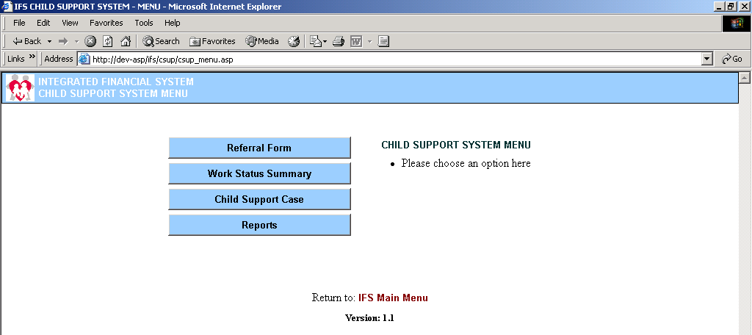

Step 2. Perform a referral search by State lD Number and/or Person ID and click the Search button.

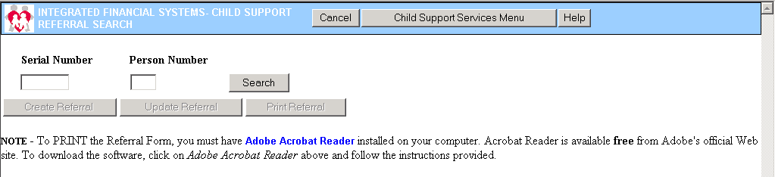

Note: The Referral Search Result displays on the lower portion of this screen.

Step 3.

A) No referral exists in IFS.

From the Referral Search Result Screen, select the CWS/CMS Child case that you want to create a referral for and Click the Create Referral button.

Note: The Update button and Print button are enabled when there is a date in the Referral Date column.

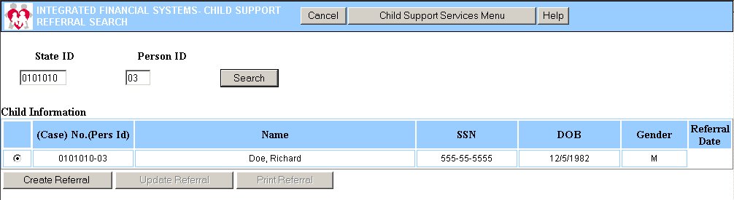

- A referral exists in IFS for a sibling.

From the Referral Search Result Screen, select the CWS/CMS Child case and the Non Custodial Parent record that you want to create a referral for and Click the Create Referral button.

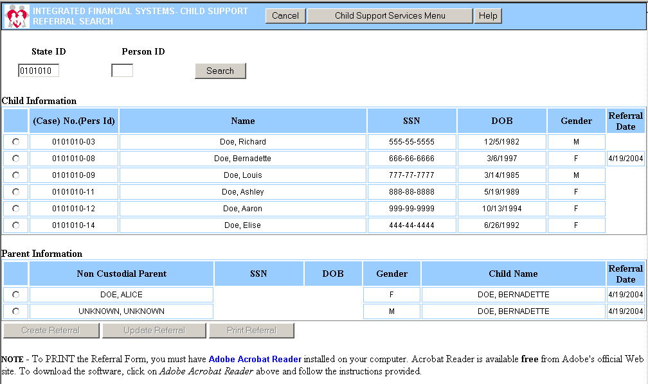
Existing Sibling Referral

Step 4. From the Referral Form Screen (child information from CWS/CMS is pre-populated), users can add referral information on the Custodial Information tab and Non Custodial Information tab and Click the Save button.

Note: Case Information data fields with in blue labels are pre-populated from CWS/CMS data and are not editable in IFS. Fields with black labels are Child Support Referral data entry fields and are editable.

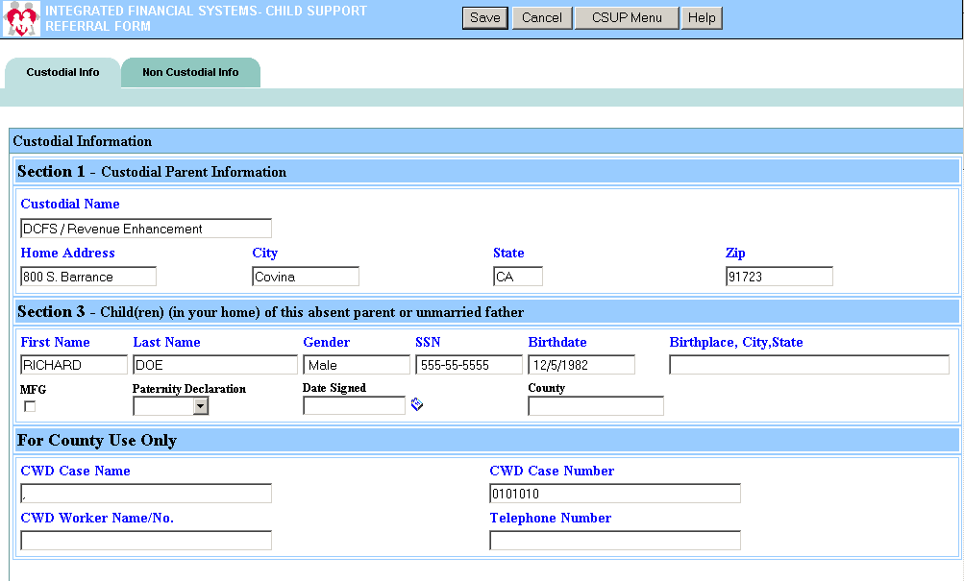
Pre-populated fields
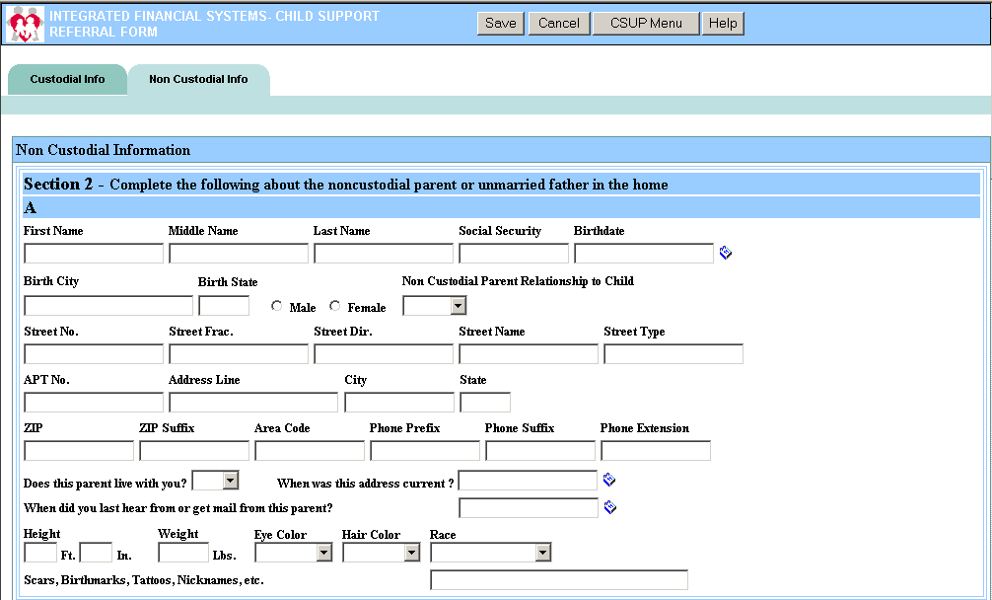
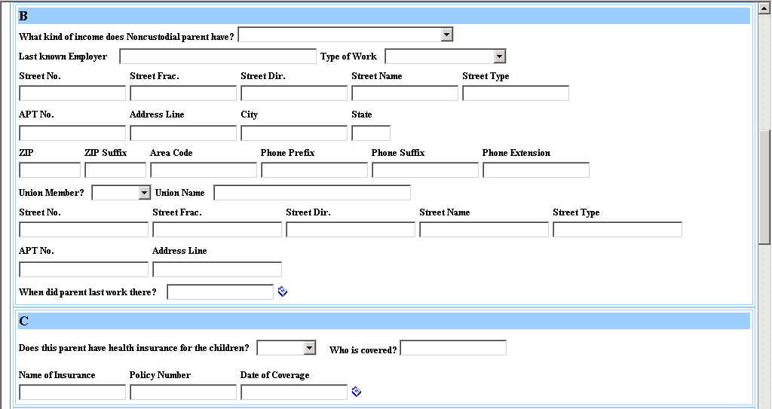
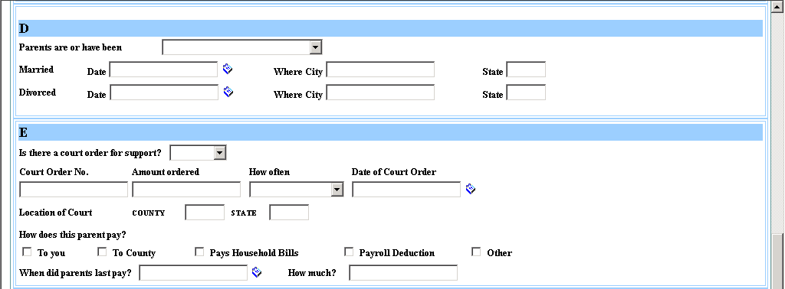
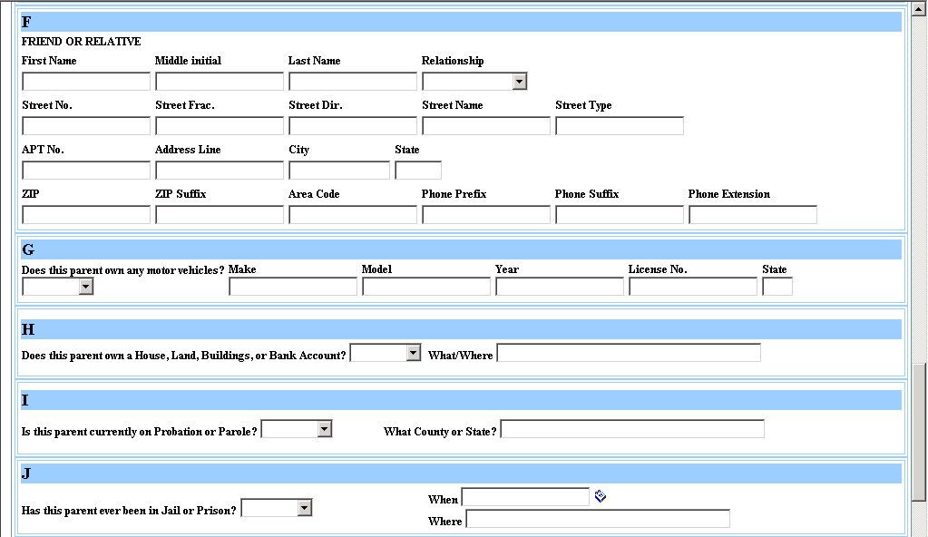
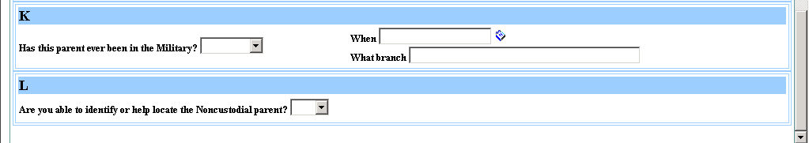

Note: Once the Save button is clicked, the Referral Search Result screen is displayed. Saving a referral will generate an automated referral record to CSSD via the Child Support interface file.

Step 4. Print Child Support CW 2.1 Referral form by clicking on the Print Referral button on the Referral Search Result screen.

NOTE – To View and PRINT the Referral Form, you must have Adobe Acrobat Reader installed on your computer. Acrobat Reader is available free from Adobe's official Web site. To download the software, go to the Adobe Acrobat Reader web site located at http://www.adobe.com/products/acrobat/readstep2.html and follow the instructions provided.

III. Updating a Referral Online

The following are steps for updating a Child Support referral:

Step 1. From the Child Support Menu click on the Referral button.

Step 2. Perform a referral search by State ID Number and/or Person ID and click the Search button.

Note: The Referral Search Result screen displays on the lower portion of this screen.

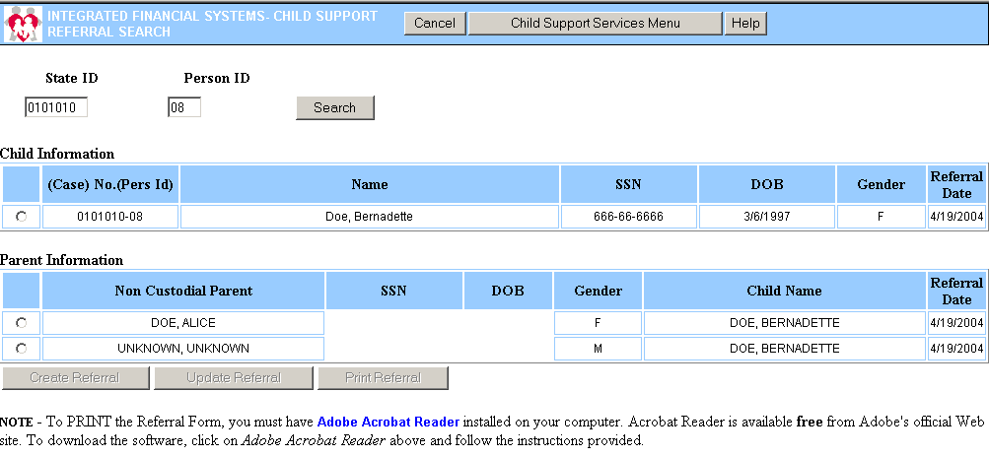

Step 3. From the Referral Search Result Screen, select the Child Support Referral that you want to update and Click the Update Referral button.

Step 4. From the Referral Form Screen, users can update referral information and Click the save button.

Saving an updated referral will generate an updated Child Support referral record to CSSD.

Step 5. Print Child Support CW 2.1 Referral form by clicking on the Print Referral button.

