Procedural Guide

E030-0540

EXTENSION OF FOSTER CARE BEYOND AGE 18

Date Issue: 05/18/12 05/30/18

New Policy Release

Revision of Existing Procedural Guide

Revision Made: This Procedural Guide has been updated per FYI 18-22, Extended Foster Care Funding and Jurisdiction Termination Date (dated 05/21/18) which is based on ACL 18-15, Last Date of Payment for Extended Foster Care (dated 02/16/18) which was issued to correct information in ACL 11-61, Extended Foster Care (dated 11/01/11). The only changes that have been made since the 05/18/12 issue date are on page 2, highlighted in yellow and are in effect as of issue date: 05/30/18.

Cancels: None.

DEPARTMENTAL VALUES

This Procedural Guide supports the Department’s priority outcomes of safety and permanency by extending foster care past the age of 18, while providing the youth with additional opportunities to engage in preparation for independent living.

WHAT CASES ARE AFFECTED

The Procedural Guide is applicable to all new and existing cases.

OPERATIONAL IMPACT

The purpose of this procedural guide is to provide instruction to eligibility regarding the policies and procedures for the Extended Foster Care (EFC) program created as a result of the passage of Assembly Bill 12. This program allows foster youth to remain in foster care after turning age 18, receive foster care benefits (Aid to Families with Dependent Children-Foster Care [AFDC-FC] payments) and services.

EFC Program Overview

The young adults who remain under the jurisdiction of the court, in EFC after age 18, are referred to as Non-Minor Dependents (NMDs). A NMD in the EFC Program remains eligible for foster care benefits as long as the NMD is meeting participation requirements, living in an approved or licensed facility, and meeting other eligibility requirements as set forth in ACL’s 11-61, 11-69, and 11-77.

The state and federal AFDC-FC program are identical, except where otherwise noted.

Program effective dates: (ACL 11-61, Extended Foster Care (EFC) and ACL 11-69, Extension of Foster Care Beyond Age 18: Part One)

Foster youth who reach age 18 and meet the participation criteria, may remain in extended foster care and continue to receive benefits and services as follows:

- Beginning January 1, 2012, up to age 19,
- Beginning January 1, 2013, up to age 20,
- Beginning January 1, 2014, up to age 21 (contingent upon Legislature approval).

Extended Foster Care (EFC) Funding and Jurisdiction Termination Date: Effective 05/30/18

Funding for EFC will no longer be available to the end of the month in which the Nonminor Dependent (NMD) ages out of foster care or the court orders termination. Per ACL 18-15, as of February 16, 2018, payment for a NMD who turns 21 shall end no later than the day before the youth’s 21st birthday.

Extended Foster Care Eligibility Criteria for Youth Who Wish To Remain in Foster Care (Acl11-61, Extended foster Care (EFC))

The following eligibility criteria are the same for both the state and federal Extended Foster Care programs and include:

- Age
- Education and Employment Participation Conditions
- Transitional Independent Living Case Plan including the Transitional Independent Living Plan (TILP) updated each six months
- Authority for placement
- Eligible facilities

If a NMD was eligible for federal AFDC-FC at the time the youth turns age 18, they remain eligible for federal AFDC-FC as long as all other eligibility conditions are met which includes the participation conditions, six-month status review hearing and the youth’s subsequent permanency planning hearings(s). A new Title IV-E determination is not necessary. If a NMD was previously eligible for state AFDC-FC benefits, they remain eligible for state AFDC-FC benefits.

Age Criteria For Extended Foster Care (EFC) (ACL 11-61 - Extended Foster Care (EFC))

In order to be eligible for EFC, a youth has to be in foster care under the placement and care responsibility of the county welfare or probation department or a Title IV-E tribe on his/her 18th birthday. In addition, the non-minor must be under the age limits specified in WIC section 11403. That is, effective January 1, 2012, a youth who was in foster care, under the jurisdiction of the juvenile court or a Title IV-E Indian tribe, on his/her 18th birthday is eligible to receive foster care until age 19 regardless of funding source.
Effective January 1, 2013, a youth who was in foster care, under the jurisdiction of the juvenile court or a Title IV-E Indian tribe on his/her 18th birthday is eligible to receive foster care benefits until age 20. The final extension to age 21 cannot occur before January 1, 2014, and requires additional action by the Legislature.

Eligible non-minors include those who:

- Are eligible for either Federal or State AFDC-FC.
- Meet any of the above circumstances and are:
  - In foster care and pregnant and/or parenting
  - In foster care and residing out-of-county or
  - In foster care and residing out-of-state.
- Are in a NRLG established through juvenile court and signed a mutual agreement to remain in foster care.

Ineligible Non-Minors include those who:

- Turn age 19 in 2011, or
- Are married, or
- Are in the military, or
- Are incarcerated, or
- Are otherwise not eligible for AFDC-FC, or
- Are in a NRLG through the probate court.

Program Participation Criteria (see ACL 11-69, attachment A, for further definition of the 5 participation conditions listed below).

To remain in EFC after attaining age 18, one (or a combination) of the following participation criteria must be met:

- Completing high school or equivalent program (i.e. GED, independent study, nonpublic school, public high school, or home schooling); OR

- Enrolled in post-secondary or vocational school; schools approved by the Bureau for Private Postsecondary Education; and courses taken through correspondence or online studies that are affiliated with a licensed institution); OR

- Participating in a program or activity that promotes or removes barriers to employment; OR

- Employed at least 80 hours per month; OR
- Eligible youth is incapable of participating in 1 through 4 above, due to a documented physical or mental condition.

Effective January 1, 2012, foster youth who are age 18 and were under juvenile court jurisdiction, are eligible for EFC up to age 19 regardless of funding source. For example, those NMDs eligible for federal AFDC-FC, state AFDC-FC or CalWORKs prior to age 18 remain eligible for those same programs after age 18 as long as all other eligibility conditions are met.

For foster youth who were previously federal/state eligible, but became ineligible at age 18 and remained under the juvenile court jurisdiction, these foster youth may be able to “re-establish” eligibility for federal/state AFDC-FC, provided they meet the new criteria under AB 12, without requiring a new IV-E eligibility determination.

Special Populations of NMDs (ACL 11-69, Extension of Foster Care Beyond Age 18: Part One)

- Former foster youth in non-dependent NRLGs established in juvenile court are eligible for extended state-only AFDC-FC payments if they meet eligibility requirements and at least one of the EFC participation criteria (listed above). Non-minor NRLG’s have an additional eligibility requirement of signing a mutual agreement for EFC, the State of California (SOC) 162 form. The SOC 162 is a condition for receipt of payment for this population (because there is no current court order for placement and care authority in these cases). Therefore, the mutual agreement serves as the authority for placement thus allowing AFDC-FC payments to be issued.

- For those NMDs whose dependency cases are governed by the Indian Child Welfare Act (ICWA), who also meet the definition of Indian Child per WIC section 224.1 (b), he/she can decide whether or not they wish for the provisions of ICWA to continue to apply to them after turning age 18.

- For eligible parenting NMDs who remain in EFC, the infant supplement for the nondependent child residing with the NMD is still available in all placements, including the SILP and THP+FC placements. Additionally, these NMDs still have the option to remain in, or be placed in, a whole foster family home which can include the THP+FC host family site (For more information refer to ACL 06-04, dated June 26, 2006 and ACL 08-24, dated June 9, 2008, regarding minor dependents and whole family foster homes).

- Those NMDs receiving Supplemental Security Income (SSI) are eligible to participate in EFC even if they receive the SSI payment benefit instead of AFDC-FC or a combination of both. If the federally eligible NMD is receiving the AFDC-FC in lieu of the SSI payment (payment placed in suspense) because the AFDC-FC payment is higher, the County shall ensure that the NMD receive state only funded AFDC-FC at least one month in any 12 month period to ensure the NMD maintains SSI eligibility at the time the youth does exit care. The county shall inform the Social Security Administration that the NMD is not receiving any FFP during that month in order to permit the NMD to receive an SSI benefit during a single month of every 12 month period. The county shall reclaim the federal AFDC-FC the following month WIC section 13757 and ACL 08-12, dated March 19, 2008, Implementation of AB 1331.

Remaining in Foster Care Beyond Age 18 (ACL 11-69, Extension of Foster Care Beyond Age 18: Part One)

Note: AB 212 will clarify that youth in a NRLG through probate court, who are eligible for state-only AFDC-FC benefits, may continue to receive the state-only benefits only up to age 19, if they continue to meet the high school completion rule via the DCFS 1725 verification process. They are not eligible for EFC program benefits. With this type of case, EW will indicate this placement type in the Special Project page as “Non-Related Probate Guardian” and include the start date. In the “description box” the EW will insert the words, “Distinguish from the AB 12 population”.

The NMD’s who choose to participate in EFC must sign the Mutual Agreement (SOC 162) at or after attaining age 18, and no longer than six months after turning 18. The SOC 162 is a required condition for participation in EFC, but not a condition of payment. The NMDs must sign the mutual agreement to acknowledge that they are voluntarily agreeing to remain in foster care in supervised placement as court dependents. The purpose of the mutual agreement is to ensure that the NMD’s status as a legal adult is recognized and to provide clear expectations to both the NMD and case manager as to what the responsibilities are for each party. The mutual agreement further specifies what services and assistance the NMDs receive from the agency. A copy of the SOC 162 must be sent to the Eligibility Worker (EW). The mutual agreement is valid throughout a continuous stay in EFC.

Note: The mutual agreement is an eligibility and benefit criterion for the non-minor residing with a non-dependent NRLG and must be signed by the youth prior to or in the month the youth attains age 18 in order for benefits to continue beyond age 18. The mutual agreement serves as the placement authority for these non-minors as there is no continuing court involvement in these cases. (Refer to MPP 45-502 (c)) for further information. If NM signs the SOC 162, after a period of separation, they are eligible to EFC).

Continuation of Placement Authority (ACL 11-69, Extension of Foster Care Beyond Age 18 - Part One)

In order for a non-minor to be eligible for extended foster care benefits, the non-minor must remain under the jurisdiction of the juvenile court as a dependent or ward and/or be under the placement and care responsibility of the county child welfare or probation department or sign the mutual agreement as a nondependent NRLG. When a foster youth reaches 18 years old, the EW shall expect the court order to remain intact until a court order terminating jurisdiction is received.

Note: A non-minor that meets the description above but who has run away from their placement remains eligible to EFC because their jurisdiction remains with Juvenile Court.

For NRLGs the placement authority is the mutual agreement and benefits will terminate when the non-minor is no longer being supported by the guardian or no longer participating in his/her Transitional Independent Living Plan (TILP).

Six-Month Certification of Extended Foster Care Participation (SOC 161) (ACL 11-69, Extension of Foster Care Beyond Age 18 - Part One)

The SOC 161 is the form that provides the EW with the necessary information for continuation of payment. The certification form will be provided to the EW to continue eligibility for extended AFDC-FC benefits. This form must be provided by the end of the first month of the next six-month certification period for continuation of Federal or State AFDC-FC. If the SOC 161 is not received timely, the aid code is changed to GRI (County) funds. When the SOC 161 is received, the aid code is changed to reflect federal/state funding effective the date showing on the SOC 161 (TILP date).

The certification covers a prospective six-month period and is updated at the same time the TILP and case plan are updated by the CSW. The SOC 161 needs to be provided to the EW.

Placement Agreement Forms (ACL 11-69, Extended Foster Care Beyond Age 18 - Part One and ACL 11-77, Extension of Foster Care Beyond Age 18: Part Two (Placement))

A new placement agreement is not needed for NMDs who remain in the same placement after turning 18. When moving NMDs to a new placement in a licensed or approved home a new placement agreement (SOC 154, 154A or 156) must be completed with the provider and copies must be forwarded to the Case Carrying or Intake EW.

Changes in placement must be reported immediately to the EW according to existing processes. If a NMD exits a placement and does not agree to be placed in another supervised licensed/approved setting or there is a disagreement between the NMD and the CSW related to a participation criteria, and the CSW/DPO will recommend the court set a WIC 391 court hearing to terminate jurisdiction. Benefits cannot be terminated until there is a court order to terminate jurisdiction, however benefits can be suspended if the NMD is not living in an eligible facility.

Placement (ACL 11-77, Extension of Foster Care Benefits Beyond Age 18: Part Two (Placement))

All placement options in any licensed or approved facility is applicable for placement with a NMD, including the new placement options THP-Plus-FC and SILP.

Group home placement for NMDs may be considered only if the continuation of the placement allows the NMD to finish high school within that academic year or is a short transition period to a more family-like or less restrictive setting. Once NMDs graduate high school or reach age 19, whichever is earlier, group home placements are prohibited unless the NMDs meet participation criteria number five, medical condition, and the group home placement is a short-term transition to the appropriate system of care (WI&C section 16501.1 (c) (1)).

A new type of placement setting called “SILP” (A Supervised Independent Living Placement) cannot be with the NMD’s biological parent(s) as the IV-E payment cannot be made to the home of removal. The SILP setting is a placement in which NMDs can live in a variety of independent setting such as an apartment (alone or with a roommate), a college dorm or a room rented from a relative, NREFM, landlord, friend or former caregiver. A SILP will receive the basic foster care rate, including any applicable clothing allowance. Payment may go directly to the NMD. The Specialized Care Increment (SCI) and dual agency rate cannot be paid for this type of placement. If the placement type is a SILP, documentation supporting the appropriateness of the placement must also be sent to the EW for filing in the NMD’s eligibility case including the SOC 157A and SOC 157B. The Readiness Assessment is not needed in the eligibility file. The beginning date of aid is not until all requirements are met. (For more information regarding a SILP placement, see CWS Procedural Guide 0100-560.40, Supervised Independent Living Plan (SILP)).

Note: The TA/EW will complete actions on CWS/CMS to set up a SILP placement and payment. (See attachment “A” for instruction on setting up a SILP).

Note: Non-minors living with a NRLG are not eligible for the above placement options, including a SILP, as they are not dependents. However, these non-minors may live in a college dorm as long as the former guardians maintain support of the non-minors. Even though this is considered a SILP for dependents, it is not considered a SILP for non-dependents and these young adults cannot directly receive the AFDC-FC payment, it must go directly to the guardian as the payee.

Another new type of placement will be called the THP-Plus-FC, created via WIC section 11403.2 (a) (3). This placement option will strictly be for the NMDs who remain in EFC as dependents of the court. The implementation of this placement type will be delayed as the state is still developing the program.

Out-of-county placements (ACL 11-69, Extension of Foster Care Beyond Age 18: Part One)

For NMDs who reside in a different county than their jurisdiction, the county of jurisdiction retains case management, and financial responsibility for NMDs.

Out-of-state placements (ACL 11-69, Extension of Foster care Beyond Age 18: Part One)

Placement out-of-state is allowable for NMDs who are attending college, residing in an approved placement or for approved TILP participation employment. The county of jurisdiction retains case management and financial responsibility for NMDs placed pursuant to ICPC. The ACL 10-56, dated December 21, 2010, refers to implementation of ICPC regulations regarding the supervision of ICPC placements.

Income - Resources

For AFDC-FC eligibility determination purposes, earned income for NMDs shall be disregarded provided that it is documented in the TILP that the purpose of employment is to enable the NMD to gain knowledge of needed work skills and the responsibilities of maintaining employment (WIC section 11008.15). As with the standard for foster care minors, NMDs may retain resources with a combined value not to exceed $10,000.

Exiting and Re-Entry to EFC (See also ACL 11-69, Extension of Foster Care Beyond Age 18: (Part One), ACL 12-12, Re-Entry into Extended Foster Care (EFC) and Procedural Guide E030-0542, Reentry into Extended Foster Care -EFC)

As NMDs are legal adults they may choose to exit foster care at any time once attaining age 18. A Termination of Jurisdiction court hearing under WIC section 391 is required. If NMD’s, eligible for EFC, exit foster care before the maximum age for that year, they have the option to reenter foster care at a later date if they agree to meet one of the participation criteria and have not yet reached the maximum age for foster care.

Young adults will not be required to meet one of the eligibility criteria at the time the young adult requests to re-enter, but will need to sign a voluntary re-entry agreement. (See procedural guide E030-0542, “Voluntary Reentry into Extended Foster Care (EFC) (SOC 163)” for further information regarding re-entry to EFC).See also ACL 12-12, Re-Entry into Extended Foster Care (EFC) dated March 23, 2012.

Grievance Process

In circumstances where there is disagreement as to whether or not a NMD is meeting the eligibility requirements or participation criteria for EFC, the determination of eligibility will be adjudicated in juvenile court under WIC 391 where they are represented by counsel, not under the Administrative Law Judge process. Payment can be stopped if the NMD is in an ineligible facility.

Procedures

Note: EW will follow the same procedures as is in Procedural Guide E090-0590, Foster Care Placement/Replacement. This includes the TA/EW setting up placement/payment on licensed facilities, and setting up the placement and non-paid payment when the placement setting requires a home assessment (i.e. relative placement). TA/EW will set up a SILP placement/payment, remembering that the SOC 157A and SOC 157B, supporting the SILP must also be attached to the DCFS 280 for completion of budgeting actions and then sent to the Intake or Case Carrying EW (See attachment “A” for instruction on setting up a SILP).

All Notices of Action (NOA) are child specific and applicable to children who were determined to be federally or State (Non-Federal) eligible. A NOA is NOT applicable if the child is GRI funded (County funds only). A NOA is completed by the individual taking the action when aid is granted or increased, denied, decreased, suspended, cancelled, discontinued or terminated. (A decrease shall include an overpayment adjustment and balancing). A NOA will also be sent when the County demands repayment of an overpayment or when the County takes action after the claimant has conditionally withdrawn a request for a State Hearing. Two (2) copies are sent to the caretaker, one (1) copy to the CSW and one (1) copy is retained in the child’s eligibility case. The NA Back 9 will be attached to all NOA’s.

All Notification Letters are child specific, applicable to children who were determined to only be eligible for GRI (County funds) to offset placement costs. The Notification Letter will be used when aid is granted or increased, denied, decreased, suspended, cancelled, discontinued or terminated. The NA Back 9 will not be attached to Notification.

Note: Relative placements require that the child must first have an eligibility determination that finds the child is eligible for foster care (federal or state funded) before foster care payment can be set up. If the child is not found to be eligible for foster care the relative may apply to CalWORKs for assistance.

CalWORKs NMD’s are required to meet the participation criteria and the DPSS EW receives the SOC 161 from the CSW. (For further information see ACL 11-78 and 11-78E, California Work Opportunity and Responsibility to Kids: Extending Benefits to Non-Minor Dependents).

AB 12 established a new category of NMDs eligible to receive extended CalWORKs benefits. An NMD is defined as a current dependent child or ward of the juvenile court who is 18, but less than 21 years of age; is in foster care under the responsibility of the
CWD or county probation department; and is participating in a transitional independent living case plan.

Note: The DCFC 280 is utilized to initiate the process for the SOC 161 to get into the youth’s eligibility case. The DCFS 280 and SOC 161 are delivered to the TA/EW, who will review CWS/CMS to obtain the placement status of the NMD. If there is a current paid placement, the TA/EW will forward the SOC 161 to Revenue Enhancement, c/o Connie Weaver. If there is a current non-paid placement and MEDS indicates a DPSS Cal-WORKS eligibility file, the TA/EW will forward the SOC 161 to DPSS Headquarters, c/o Tegest Tekie, 12820 Crossroads Parkway South, Industry, CA 91746. Effective 1/1/2012, this same process will also be in effect for the Mutual Agreement for Extended Foster Care (SOC 162).

WHEN: UPON RECEIPT OF THE DCFS 280 REQUESTING A FOSTER CARE PLACEMENT PACKET AND MEDI-CAL CARD FOR A NMD

Technical Assistant Unit

  - Receive the DCFS 280 and other documentation including the SOC 161 from the CSW for a NMD. The packet may also have additional documents such as the SOC 162 (See the bottom of page 3 and top of page 4 for further information regarding the SOC 162), SOC 815 (if placed with a relative/NREFM etc), SOC 157A and SOC 157B (for SILP) etc.

  - Review the documentation and determine if all mandatory information and signatures is provided, authorizing the approved placement/payment selection.

    - If the mandatory signatures are not in place or the information is not complete, return the documentation to the requesting CSW for correction.

      - Flag the Workload Management Log to indicate that the documentation has been returned for correction.
      - Check with the CSW/SCSW after 5 days if the corrected documentation has not been returned as the assignment may have been cancelled.

  - Upon return of the documentation, with necessary corrections, open the youth’s Medi-Cal and CWS/CMS case and determine the following:

    - Is the youth in Non-Paid Placement with a relative in receipt of CalWORKs?

        - If the youth is placed in Non-Paid Placement with a relative, who is in receipt of CalWORKs, annotate the office location and CalWORKs EW file number at the top of the SOC 161.

        - Send the SOC 161 to the DPSS Centralized Location: c/o Tegest Tekie at 12820 Crossroads Parkway South, Industry, CA 91746.

    - Is the youth receiving foster care funding for an out-of-home placement?

      - If this a new placement/replacement the TA/EW will data enter the placement/budgeting information into CWS/CMS per current departmental procedures in E090-0590, Foster Care Placement/Replacement. (Reminder: TA/EW will complete placement and budgeting actions only on placements that are licensed, however if the home requires an assessment they will set up a non-paid placement (also see ii below)). All documentation will be forwarded to the Intake or Redetermination EW for completion of assignment, follow-up or filing of documents in the child’s eligibility case.

      - If the DCFS 280 indicates this is a SILP, and the SOC 157A and SOC 157B are not attached or incomplete, this placement will be set up as a non-paid placement, however, if the required documentation is attached and accurate, follow instruction as indicated in Attachment “A” and set up the placement/budget.

      - If the NMD is in an ongoing placement go to step 5.

    - The effective date of EFC will be the same date indicated on the SOC 161 under “Nonminor’s Transitional Independent Living Plan (TILP) was updated on “__________”.”

  - If there is no assigned Intake or Redetermination EW, set up the primary participation criteria code in the Special Project page on CWS/CMS (see page 3 for a listing of the 5 types of participation criteria). This information is located on the SOC 161 submitted by the CSW. (If there is an assigned Intake or Redetermination EW, they will set up the primary participation criteria code.) (See page Attachment A for instruction on setting up the primary participation criteria code.)

Note: When there is a change from one participation code to another, the EW will remember to stop the 1st participation code on the Special Projects Page, while setting up the start date for the 2nd participation code.

- TA/EW will not change the aid code. If there is question as to correctness, bring it to the attention of the TA/ES for clarification and or approval for the change.

- If this is a change in placement or aid code, ensure that a referral is sent to the Centralized Medi-Cal unit with the correct information.

- Complete case notes, indicating the actions taken in the case.

  - Forward the DCFS 280, original SOC 161 and other attached documentation to the Intake or Case Carrying EW/designated EW.

  - Follow current procedures with regard to updating the Workload Management Log.

Case Carrying Unit Responsibilities

- Receive documentation from the TA/EW Unit.

- Unit Clerk/Eligibility Supervisor will forward the SOC 161 and accompanying documentation to the assigned EW.

- Assigned EW will review the child’s case and documentation on CWS/CMS and MEDS to ensure that all information data entered is correct, including the placement, payment, aid code, and Special Project page.
  - If there is error, follow departmental processes for returning or correction of error.

- Once corrected, follow processes as outlined in procedural guide E090-0590, Foster Care Placement/Replacement to complete necessary budgeting actions (when applicable).

  - The six-month control (DCFS 26-1) for the next certification period will be six-months from the TILP date as indicated on the SOC 161.

- Set up the primary participation criteria code in the Special Project page on CWS/CMS (For further information see page 3 for a listing of the 5 types of participation criteria). This information is located on the SOC 161 submitted by the CSW (See Attachment A for further instruction on setting up the primary participation criteria code in the Special Project page).

- Document all actions taken on the case in CWS/CMS case notes.

- File all documentation in the eligibility case on the left side of the Income Maintenance folder.

OVERVIEW OF STATUTES/REGULATIONS:

Assembly Bill (AB) 12

Public Law (PL) 110- 351

Welfare and Institutions Code (WIC)

Manual of Policies and Procedures (MPP)
All County Letters (ACL) 12-05, 11-77, 11-69, 11-61, 10-56, 08-31, 08-24, 08-12, and 06-04

All County Information Notice (ACIN) 1-40-11

LINKS:

California Code http://www.leginfo.ca.gov/calaw.html
Division 31 Regulations http://www.cdss.ca.gov.ord/PG309.htm
Title 22 Regulations http://www.dss.cahwnet.gov/ord/PG295.htm

RELATED POLICIES - FOSTER CARE:

E030-0542 Reentry into Extended Foster Care (EFC)
E090-0590 Foster Care Placement/Replacement

RELATED POLICIES - CWS:

0100-535.25 Extended Foster Care (EFC) Program
0100-560.40 Supervised Independent Living Plan (SILP)
0100-535.65 Extended Foster Care: Re-Entry of Nonminor Dependent

FORMS:

DCFS 280 Technical Assistant Action Request
SOC 153 Foster Family Agency Placement Agreement
SOC 154B Group Home Agreement
SOC 156A Foster Parents Placement Agreement
SOC 157A Supervised Independent Living Plan (SILP) Approval and Placement Agreement
SOC 157B Supervised Independent Living Plan (SILP) Checklist of Facility Health and Safety Standards
SOC 161 Six-Month Certification of Extended Foster Care Participation
SOC 162 Mutual Agreement for Extended Foster Care

Non-Minor Dependent (NMD or NM) SILP Placement Information

Step 1

Click on the green button and check the Special Project page to determine if the SOC 161 and SOC 162 were submitted by CSW.

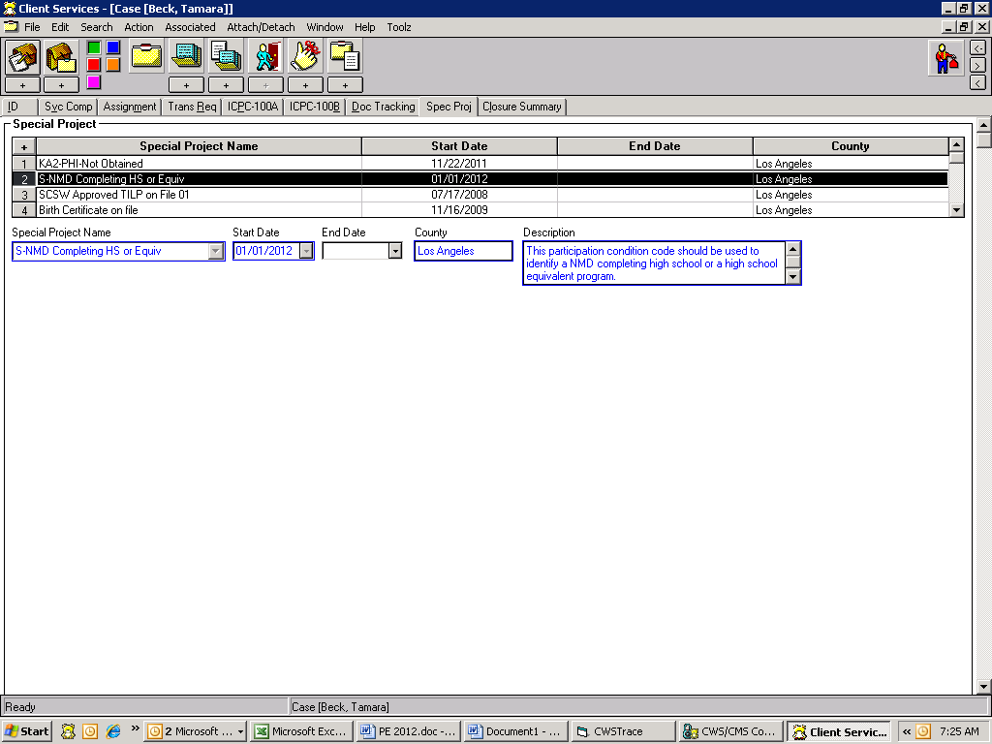

Step 2

Click on the red button, then on the second house “+” sign to the right to create a new placement home.

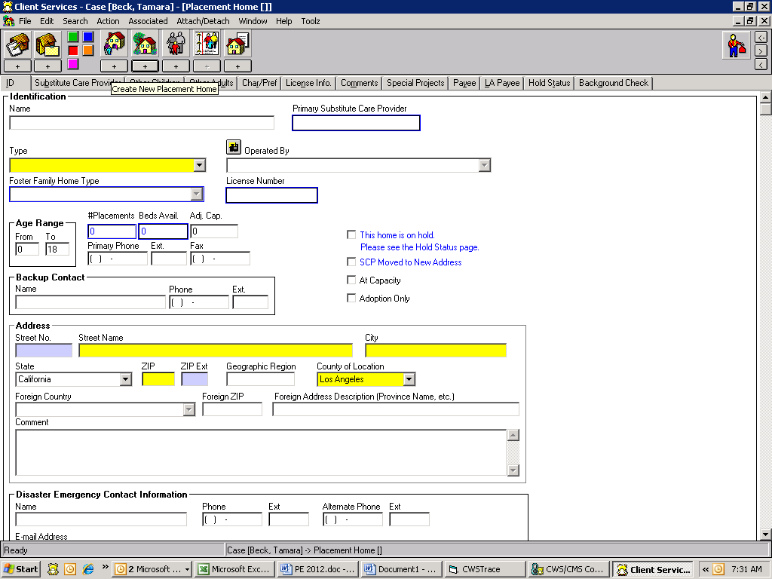

Step 3

You will complete the ID page as usual EXCEPT you must select the Placement Home Type of “Court Specified Home” for SILP placements. (Do not send RM200 to Resource Management for SILP placement). The system will generate the vendor number, however, if after 24 business hours since the placement was created, if you find that the vendor number has not been created, contact the Supervisor over the Resource Management Unit for assistance with setting up the vendor number.

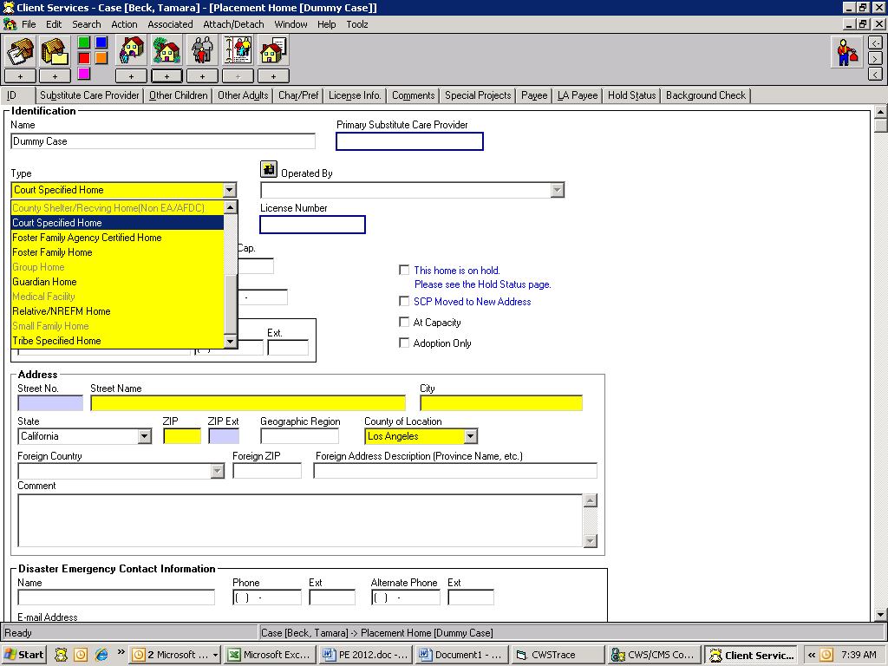

Step 4

Complete the Substitute Care Provider page as usual.

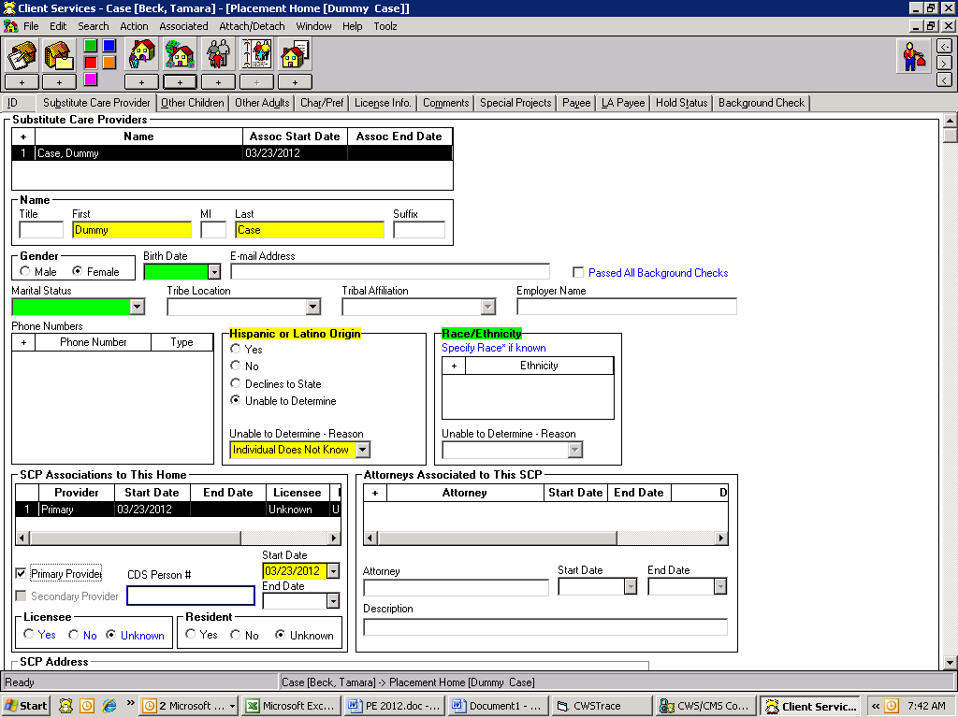

Step 5

Create a Special Project for all SILP placement homes by clicking on the ‘+’ sign and selecting ‘S-NMD SILP’

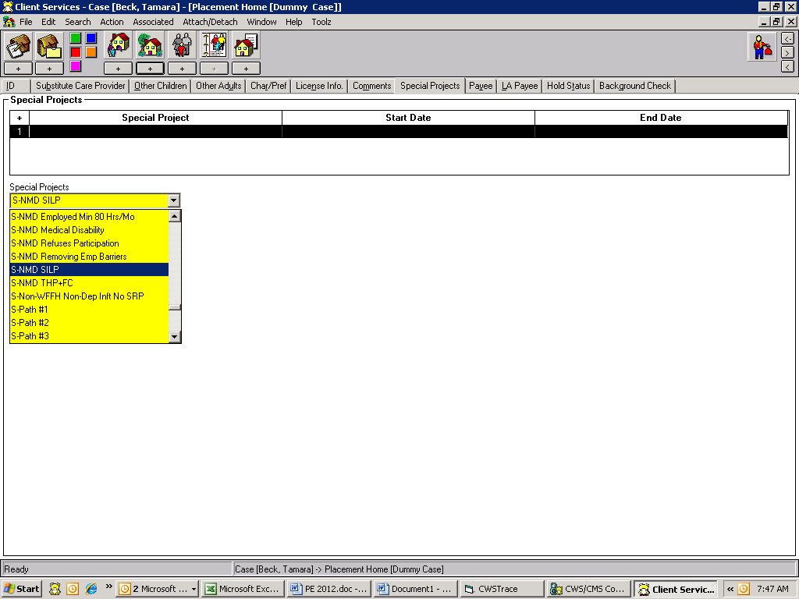

Step 6

Enter the Start Date for the Special Project which should match the Start Date of SILP placement.

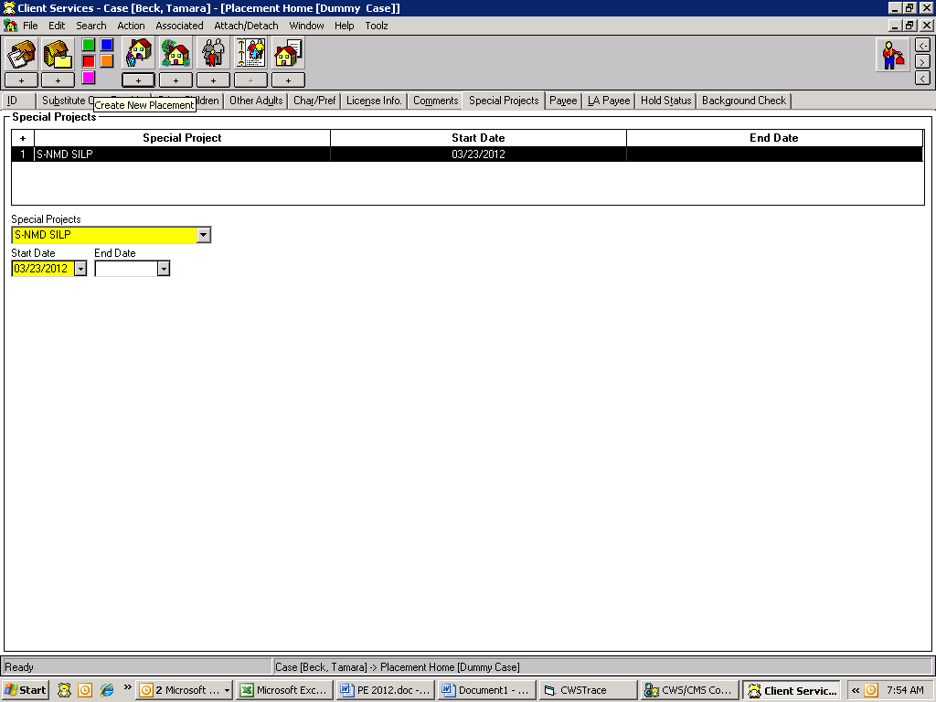

Step 7

Now you have completed adding the home. Click on ‘+’ sign under first house to create placement. Select the SILP home you created and click OK button.

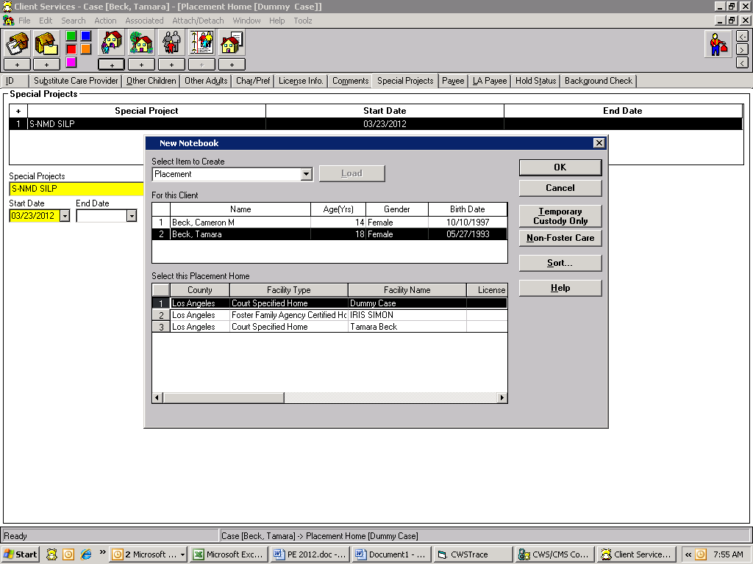

Step 8

ID page on placement, Select “Nonrelatives-Nonguardian” as Care Provider Relationship.

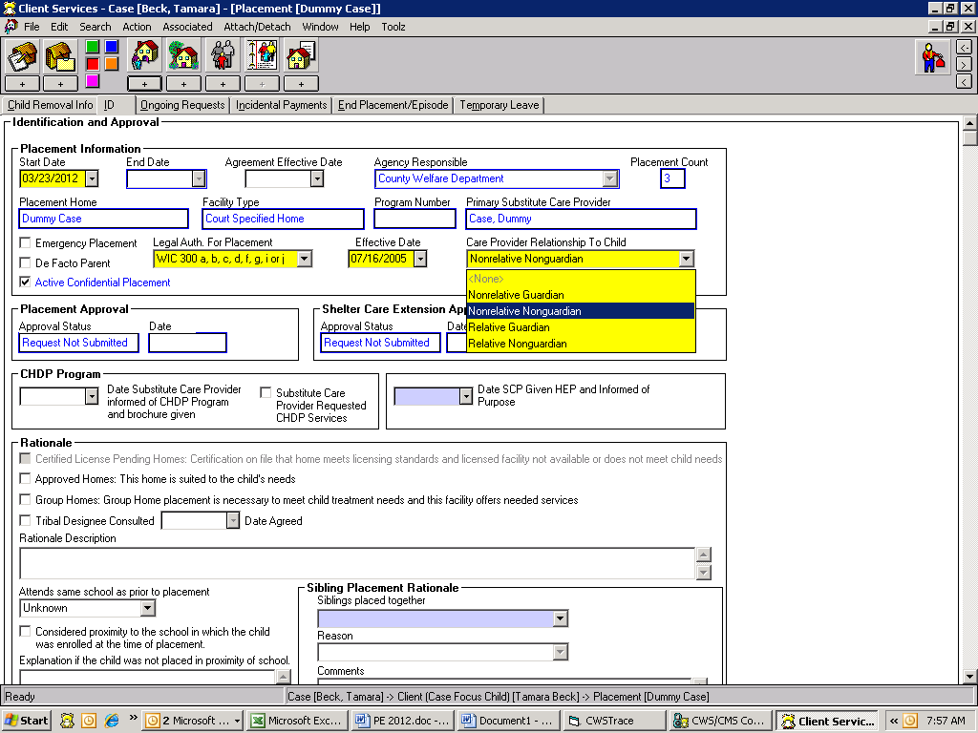

Step 9

Go to the Ongoing Page of placement, Start Date of payment is CSW signature date on SOC 157 A or placement date, which ever comes later. NM (NMD) is eligible for Basic rate only.

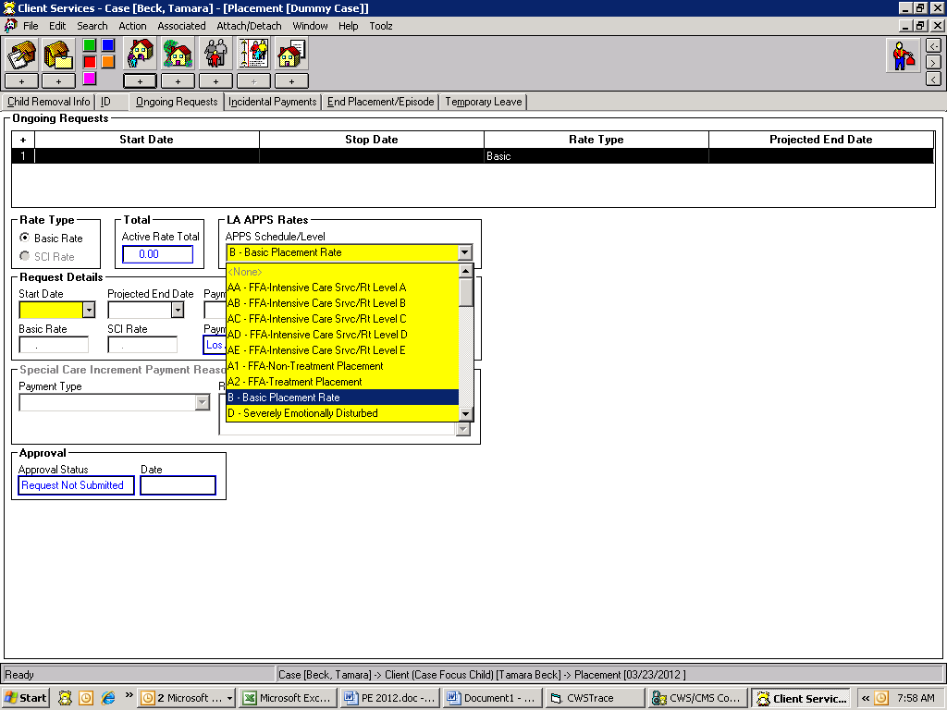

Step 10

The aid code remains the same. (State or Federal).

