Extension of Foster Care Beyond Age 18
E030-0540 | Revision Date: 10/04/2023

Overview

The purpose of this procedural guide is to provide instruction to eligibility regarding the policies and procedures for the Extended Foster Care (EFC) program created as a result of the passage of Assembly Bill 12. This program allows foster youth to remain in foster care after turning age 18, receive foster care benefits (Aid to Families with Dependent Children-Foster Care [AFDC-FC] payments and services.

TABLE OF CONTENTS

Policy
Extended foster Care (EFC) Program
Program Effective Dates
EFC Funding and Jurisdiction Termination Date
EFC Eligibility Criteria for Youth Who Wish to Remain in Foster Care
Age Criteria for EFC
Eligible Non-Minors
Ineligible Non-Minors
Program Participation Criteria
Special Population of Non-Minor Dependents (NMD)
Remaining in Foster Care Beyond the Age of 18
Continuation of Placement Authority
Six Months Certification of EFC Participation (SOC161)
Placement Agreement Forms
Placement
Out of County Placements
Out of State Placements
Income-Resources
Exiting and Re-Entry to EFC
Grievance Process
Notice of Action (NOA)
Procedure
Upon Receipt of the DCFS Auto 280 Requesting Foster Care Placement Packet and Medi-Cal Card for NMD
Technical Assistant/Eligibility Worker (TA/EW) Responsibilities
Intake/Redetermination EW Responsibilities
Helpful Links
Forms
Related Policies
Statues
Links

Version Summary

This policy guide was updated from the 05/30/2018 revision of the existing policy dated 05/18/2012, which includes the updated for extended foster care funding and jurisdiction termination date, information found in the All County Letter (ACL) 18-15, the last date of payment for extended foster care, corrected information from ACL 11-61. This policy Guide has been revised in an updated format, and reflects current procedures to align with the implementation of the California Statewide Automated Welfare System (CalSAWS).

POLICY

Extended Foster Care (EFC) Program

The young adults who remain under the jurisdiction of the court, in EFC after age 18, are referred to as Nonminor Dependents (NMDs). A NMD in the EFC Program remains eligible for foster care benefits as long as the NMD is meeting participation requirements, living in an approved or licensed facility, and meeting other eligibility requirements such as: six-month status review hearing and the youth’s subsequent permanency planning hearing(s).

EFC Funding and Jurisdiction Termination Date

Funding for EFC will no longer be available to the end of the month in which the NMD ages out of foster care. As of February 16, 2018, payment for a NMD who turns 21 shall end no later than the day before the youth’s 21st birthday or the date the court orders termination of jurisdiction.

Program Participation Conditions

To remain in EFC after attaining age 18, one or a combination of the following participation criteria must be met:

- Completing high school or equivalent program (i.e. GED, independent study, nonpublic school, public high school, or home schooling).

- Enrolled in post-secondary or vocational school; schools approved by the Bureau for Private Postsecondary Education; and courses taken through correspondence or online studies that are affiliated with a licensed institution.

- Participating in a program or activity that promotes or removes barriers to employment.

- Employed at least 80 hours per month.

- Eligible youth is incapable of participating in 1 through 4 above, due to a documented physical or mental condition.

Effective January 1, 2012, foster youth who are age 18 and were under juvenile court jurisdiction, are eligible for EFC up to age 21 regardless of funding source. For example, those NMDs eligible for federal AFDC-FC, state AFDC-FC or CalWORKs prior to age 18 remain eligible for those same programs after age 18 as long as all other eligibility conditions are met.

For foster youth who were previously federal/state eligible, but became ineligible at age 18 and remained under the juvenile court jurisdiction, these foster youth may be able to “re-establish” eligibility for federal/state AFDC-FC, provided they meet the new criteria under AB 12, without requiring a new IV-E eligibility determination.

EFC Eligibility Criteria for Youth Who Wish to Remain in Foster Care

The following eligibility criteria are the same for both the state and federal Extended Foster Care programs and include:
- Age
- Education and Employment Participation Conditions
- Transitional Independent Living Case Plan including the Transitional Independent Living Plan & Agreement (TILP 1) updated each six months
- Authority for placement
- Eligible facilities

If a NMD was eligible for federal AFDC-FC at the time the youth turns age 18, they remain eligible for federal AFDC-FC as long as all other eligibility conditions are met which includes:
- The participation conditions,
- The six-month status review hearing and the youth’s subsequent permanency planning hearing(s) (SOC 161).
- A new Title IV-E determination is not necessary.

NMDs who were ineligible for federal financial participation (FFP) prior to attaining 18 years of age, and who consent to file a petition with the juvenile court to dismiss dependency or transition jurisdiction, and immediately resume that jurisdiction in order to establish the NMD’s eligibility for FFP.
- The juvenile court may grant this petition without the need for a hearing.

Prior to initiating the juvenile court petition process, the Eligibility Worker (EW) and case carrying Children Social Worker (CSW) need to conduct a review in order to ensure that all other federal eligibility requirements will be met when making a new Title IV-E eligibility determination after the petition is granted. A county child welfare, probation, or tribal placing agency shall not file a petition of dismissal of dependency if any of the following circumstances are present:
- The NMD is categorically ineligible for federal Aid to AFDC-FC benefits.
- The NMD is a member of a tribe or eligible for enrollment in a tribe, and would likely become ineligible for services or supports, or have benefits disrupted if the county sought to establish eligibility for FFP.

Age Criteria for EFC

In order to be eligible for EFC, a youth has to be in foster care under the placement and care responsibility of the county welfare or probation department or a Title IV-E tribe on their 18th birthday. In addition, the nonminor must be under the following age limits specified in WIC section 11403:

Effective January 1, 2012, a youth who was in foster care, under the jurisdiction of the juvenile court or a Title IV-E Indian tribe, on their 18th birthday is eligible to receive foster care until age 19 regardless of funding source.

Effective January 1, 2013, a youth who was in foster care, under the jurisdiction of the juvenile court or a Title IV-E Indian tribe on their 18th birthday is eligible to receive foster care benefits until age 20.

The final extension to age 21 cannot occur before January 1, 2014, and requires additional action by the Legislature.

Eligible NonMinors
- Youths that are eligible for either Federal or State AFDC-FC.
- Youths that meet any of the above circumstances and are:
  - In foster care and pregnant and/or parenting.
  - In foster care and residing out-of-county.
  - In foster care and residing out-of-state.
- Youths that are in a NRLG established through juvenile court and signed a mutual agreement to remain in foster care.
- Youth who are married
- Youth that are enlisted in the military (non-active).

Ineligible NonMinors
- Youth who are in active military duty
- Youth who are incarcerated
- Youth who are otherwise not eligible for AFDC-FC
- Youth who are in a NRLG through the probate court

Special Populations of NMDs

- Former foster youth in non-dependent NRLGs established in juvenile court are eligible for extended state-only AFDC-FC payments if they meet eligibility requirements and at least one of the EFC participation conditions. Nonminor NRLG’s have an additional eligibility requirement of signing the Mutual Agreement for Extended Foster Care, SOC162 form.
    - The SOC 162 is a condition for receipt of payment for this population because there is no current court order for placement and care authority in these cases. Therefore, the mutual agreement serves as the authority for placement thus allowing AFDC-FC payments to be issued.
- For those NMDs whose dependency cases are governed by the Indian Child Welfare Act (ICWA), who also meet the definition of Indian Child per WIC section 224.1 (b), they can decide whether or not they wish for the provisions of ICWA to continue to apply to them after turning age 18.
- For eligible parenting NMDs who remain in EFC, the infant supplement for the nondependent child residing with the NMD is still available in all placements, including the Supervised Independent Living Placement (SILP) and Transitional Housing Placement (THP)+FC placements. Additionally, these NMDs still have the option to remain in, or be placed in, a whole foster family home which can include the THP+FC host family site.
- Those NMDs receiving Supplemental Security Income (SSI) are eligible to participate in EFC even if they receive the SSI payment benefit instead of AFDC-FC or a combination of both. If the federally eligible NMD is receiving the AFDC-FC in lieu of the SSI payment (payment placed in suspense) because the AFDC-FC payment is higher. The County shall ensure that the NMD receive state only funded AFDC-FC at least one month in any 12-month period to ensure the NMD maintains SSI eligibility at the time the youth exits care. The county shall inform the Social Security Administration that the NMD is not receiving any FFP during that month in order to permit the NMD to receive an SSI benefit during a single month of every period. The county shall reclaim the federal AFDC-FC the following month.
- California Regional Centers are nonprofit private corporations that contract with the State Department of Developmental Services to provide or coordinate services and supports for individuals with developmental disabilities. Developmental disability [WIC 4512(a)] is define as a disability that originates before an individual attains age 18 years, continues, or can be expected to continue, indefinitely, and constitutes a substantial disability for that individual. This may include mental retardation, cerebral palsy, epilepsy, and autism. It also includes disabling conditions found to be closely related to mental retardation or to require treatment similar to that required for individuals with mental retardation, but shall not include other handicapping conditions that are solely physical in nature.

Remaining in Foster Care Beyond the Age of 18

The NMDs who choose to participate in EFC must sign the SOC 162 at or after attaining age 18, and no longer than six months after turning 18. The SOC 162 is a required condition for participation in EFC, but not a condition of payment. The NMDs must sign the mutual agreement to acknowledge that they are voluntarily agreeing to remain in foster care in supervised placement as court dependents. The purpose of the mutual agreement is to ensure that the NMD’s status as a legal adult is recognized and to provide clear expectations to both the NMD and case manager as to what the responsibilities are for each party. The mutual agreement further specifies what services and assistance the NMDs receive from the agency. A copy of the SOC 162 must be sent to the Eligibility Worker (EW). The mutual agreement is valid throughout a continuous stay in EFC.
- The mutual agreement is an eligibility and benefit criterion for the nonminor residing with a non-dependent NRLG and must be signed by the youth prior to or in the month the youth attains age 18 in order for benefits to continue beyond age 18. The mutual agreement serves as the placement authority for these non-minors as there is no continuing court involvement in these cases. If the nonminor signs the SOC 162, after a period of separation, they are eligible to EFC.
- AB 212 will clarify that youth in a NRLG placement through probate court, who are eligible for state-only AFDC-FC benefits, may continue to receive the state-only benefits only up to age 19, if they continue to meet the high school completion rule via the School Verification, DCFS 1725 verification process. They are not eligible for EFC program benefits. With this type of case, the EW will indicate this placement type in the Special Project page as “Non-Related Probate Guardian” and include the start date. In the “description box” the EW will insert the words, “Distinguish from the AB 12 population”.

Continuation of Placement Authority

In order for a nonminor to be eligible for extended foster care benefits, the nonminor must remain under the jurisdiction of the juvenile court as a dependent or ward, and/or be under the placement and care responsibility of the county child welfare or probation department, or sign the mutual agreement as a nondependent NRLG. When a foster youth reaches 18 years old, the EW shall expect the court order to remain intact until a court order terminating jurisdiction is received.
- A nonminor that meets the description above but who has run away from their placement remains eligible to EFC because their jurisdiction remains with Juvenile Court.

For NRLGs the placement authority is the mutual agreement, and benefits will terminate when the nonminor is no longer being supported by the guardian or no longer participating in their Transitional Independent Living Plan (TILP).

Six Months Certification of EFC Participation (SOC 161)

The SOC 161 is the form that provides the EW with the necessary information for continuation of payment. The certification form is to be provided to the Redetermination EW to continue eligibility for extended AFDC-FC benefits. This form must be provided by the end of the first month of the next six-month certification period for continuation of Federal or State AFDC-FC. If the SOC 161 is not received timely, the aid code is changed to GRI (County) funds. When the SOC 161 is received, the aid code is changed to reflect federal/state funding effective the date showing on the SOC 161 (TILP date).

The certification covers a prospective six-month period and is updated at the same time the TILP and case plan are updated by the CSW. The CSW is to submit the SOC 161 to the Redetermination EW via Technical Assistant/Eligibility Worker (TA/EW).
- Upon receipt of the SOC 161, the AB12 EW and the AB 12 Eligibility Supervisor (ES) are to complete signing the form.

Placement Agreement Forms

A new placement agreement is not needed for NMDs who remain in the same placement after turning 18. When moving NMDs to a new placement in a licensed or approved home a new placement agreement Agency Group Home Agreement, SOC 154, Placement Agency-Foster Family Agency Agreement, SOC 154A or Agency Foster Parents Agreement SOC 156 must be completed with the provider and copies must be forwarded to the Intake or Redetermination EW.

Changes in placement must be reported immediately to the EW according to existing processes. If a NMD exits a placement and does not agree to be placed in another supervised licensed/approved setting, or there is a disagreement between the NMD and the CSW related to a participation condition, and the CSW/DPO will recommend the court set a WIC 391 court hearing to terminate jurisdiction. Benefits cannot be terminated until there is a court order to terminate jurisdiction, however benefits can be suspended if the NMD is living in an unapproved facility.

Placement

All placement options in any licensed or approved facility is applicable for placement with a NMD, including the new placement options THP-NMD and SILP.

Group home placement for NMDs may be considered only if the continuation of the placement allows the NMD to finish high school within that academic year or is a short transition period to a more family-like or less restrictive setting. Once the NMDs graduate high school or reach age 19, whichever is earlier, group home placements are prohibited unless the NMDs meet participation condition number five (5), medical condition, and the group home placement is a short-term transition to the appropriate system of care (WIC section 16501.1 (c) (1)).

The Supervised Independent Living Placement (SILP) setting is a placement in which NMDs can live in a variety of independent setting such as an apartment (alone or with a roommate), a college dorm or a room rented from a relative, Non Related Extended Family Member (NREFM), landlord, friend or former caregiver.

A SILP NMD living with a parent; the term “parent” refers to both a parent from whom the youth was removed or any non-custodial parent. This can include, but is not limited to, a biological parent, guardian or adoptive parent. It is important to note that the NMD is not being placed with the parent, being returned home to the parent or in any way under the care or supervision of the parent.

The NMD remains a dependent or ward of the juvenile court under the placement and care supervision of the county placing agency and must continue to meet all eligibility criteria for EFC, and must continue to work with the child welfare agency or probation department towards achieving independence, including maintaining monthly contact with their social worker/probation officer. This policy change only applies to NMDs, determined to be ready for a SILP through a SILP readiness assessment, where a parent(s) will also be residing.

A SILP will receive the basic foster care rate, including any applicable clothing allowance. Payment may go directly to the NMD. The Specialized Care Increment (SCI) and dual agency rate cannot be paid for this type of placement. If the placement type is a SILP, documentation supporting the appropriateness of the placement must also be sent to the EW for filing in the NMD’s eligibility case including the SILP Approval and Placement Agreement, SOC 157A and SILP Inspection Check List SOC 157B. The Standardized SILP Readiness Assessment (SOC 157C) is not needed in the eligibility file. The beginning date of aid is not until all requirements are met. For more information regarding a SILP placement, see CWS Procedural Guide 0100-560.40 Supervised Independent Living Plan (SILP).
- TA/EW will complete actions on CWS/CMS to set up a SILP placement and payment.
- Nonminors living with a NRLG are not eligible for the above placement options, including a SILP, as they are not dependents. However, these nonminors may live in a college dorm as long as the former guardians maintain support of the nonminors. Even though this is considered a SILP for dependents, it is not considered a SILP for non-dependents and these young adults cannot directly receive the AFDC-FC payment, it must go directly to the guardian as the payee.

Another type of placement called the THP-NMD was created via WIC 11403.2 (a) (3). This placement option is strictly for the NMDs who remain in EFC as dependents of the court.

Out of County Placements

For NMDs who reside in a different county than their jurisdiction, the county of jurisdiction retains case management, and financial responsibility for NMDs.

Out of State Placements

Placement out-of-state is allowable for NMDs who are attending college, residing in an approved placement or for approved TILP participation employment. The county of jurisdiction retains case management and financial responsibility for NMDs placed pursuant to Interstate Compact on the Placement of Children (ICPC) referring to the implementation and regulations regarding the supervision of ICPC placements.

Income – Resources

For AFDC-FC eligibility determination purposes, earned income for NMDs shall be disregarded provided that it is documented in the Transitional Independent Living Plan TILP 1 that the purpose of employment is to enable the NMD to gain knowledge of needed work skills and the responsibilities of maintaining employment (WIC section 11008.15). As with the standard for foster care minors, NMDs may retain resources with a combined value not to exceed $10,000.

Exiting and Re-Entry to EFC

As NMDs are legal adults they may choose to exit foster care at any time once attaining age 18. A Termination of Jurisdiction court hearing under WIC section 391 is required. If NMDs eligible for EFC, exit foster care before the maximum age of 21 for that year, they have the option to re-enter foster care at a later date if they agree to meet one of the participation conditions and have not yet reached the maximum age for foster care.

Young adults will not be required to meet one of the eligibility criteria at the time the young adult requests to re-enter, but will need to sign a Voluntary Re-entry Agreement for Extended Foster Care, SOC 163.

Grievance Process

In circumstances where there is disagreement as to whether or not a NMD is meeting the eligibility requirements or participation criteria for EFC, the determination of eligibility will be adjudicated in juvenile court under WIC 391 where they are represented by counsel, not under the Administrative Law Judge process. Payment can be stopped if the NMD is in an ineligible facility.

Notice of Action (NOA)

All Notices of Action (NOA) are child specific and applicable to children who were determined to be federally or State (Non-Federal) eligible. An NOA is not applicable if the child is GRI funded.

An NOA is completed by the EW taking the action when aid is granted, increased, decreased, discontinued, deferred, terminated and/or request for a rate change is denied.

For a rate decrease, a notice of action should be sent at least ten (10) days prior to the rate decrease

An NOA will also be sent when the County demands repayment of an overpayment or when the County takes action after the claimant has conditionally withdrawn a request for a State Hearing. Two (2) copies are sent to the caretaker, one (1) copy to the CSW and one (1) copy is retained in the child’s eligibility case.

The NA Back 9 provides information to request an appeal, and it will be attached to applicable NOA’s.

All Notification Letters are child specific, applicable to children who were determined to only be eligible for GRI to offset placement costs. The Notification Letter will be used when aid is granted or increased, denied, decreased, suspended, cancelled, discontinued or terminated. The NA Back 9 will not be attached to Notification Letters.

PROCEDURE

Technical Assistant/Eligibility Worker (TA/EW) Responsibilities

The DCFS 280 is utilized to initiate the process for the SOC 161 to get into the youth’s eligibility case. The DCFS 280 and SOC 161 are delivered to the TA/EW via the Foster Care Search System (FCSS), the TA/EW is to review CWS/CMS to obtain the placement status of the NMD.
- If there is a current paid placement, the TA/EW will forward the SOC 161 and the Mutual Agreement for Extended Foster Care SOC 162 to the Revenue Enhancement Division (RED) at DCFSSOC161@dcfs.lacounty.gov .
- If there is a current non-paid placement and MEDS indicates a Department of Public and Social Services (DPSS) Cal-WORKS eligibility file, the case carrying CSW will forward the SOC 161 to DPSS District Office

The TA/EW is to set up placement/payment for probationary Emergency Care (EC) funding or approved Resource Family Home (RFH), licensed facilities.
- A SILP non-paid placement is to be set up when the placement requires a home assessment.

The TA/EW will set up a SILP placement/payment, remembering that the SOC 157A and SOC 157B, supporting the SILP must also be attached to the DCFS 280 for completion of budgeting actions and then sent to the Intake or Redetermination Eligibility Worker (EW) by following instructions under Attachment A.

Relative placements require that the child must first have an eligibility determination that finds the child is eligible for foster care (federal or state funded) before foster care payment can be set up. If the child is not found to be eligible for Foster Care the relative may apply to California Work Opportunity and Responsibility to Kids (CalWORKS) for assistance.

CalWORKs NMD’s are required to meet the participation criteria and the Department of Public and Social Services (DPSS) EW receives the SOC 161 from the CSW. (For further information, see ACL 11-78 and 11-78E, California Work Opportunity and Responsibility to Kids: Extending Benefits to Non-Minor Dependents.

AB 12 established a new category of NMDs eligible to receive extended CalWORKs benefits. An NMD is defined as a current dependent child or ward of the juvenile court who is 18, but less than 21 years of age; is in foster care under the responsibility of the Children Welfare Department (CWD) or the County Probation Department; and is participating in a transitional independent living case plan.

Upon Receipt of the DCFS 280 Requesting a Foster Care Placement Packet and Medi-Cal Card for a Re-Entry of an NMD

TA/EW Responsibilities

  - Receive the DCFS 280 requesting a Foster Care Placement Packet which includes the following documentation:
- SOC 163, Voluntary Re-Entry Agreement For Extended Foster Care
- SOC 161, Six-Month Certification of Extended Foster Care Participation (from the CSW for a NMD)
The packet may also have additional documents such as the following:
- SOC 162, Mutual Agreement For Extended Foster Care
- RFA 5A, Resource Family Approval Certificate (if placed with a relative/NREFM etc)
- SOC 157A, The Supervised Independent Living Placement (SILP) Approval and Placement Agreement
- SOC 157B, The SILP Inspection: Checklist of Facility Health and Safety Standards.

  - Review the documentation and determine if all mandatory information and signatures are provided, authorizing the approved placement/payment selection.
    - If the mandatory signatures are not in place or the information is not complete, return the documentation to the requesting CSW for correction.
      - Flag the Workload Management Log to indicate that the documentation has been returned for correction.
      - Check with the CSW/SCSW after 5 days if the corrected documentation has not been returned as the assignment may have been cancelled.

  - Upon return of the documentation, with necessary corrections, open the youth’s Medi-Cal and CWS/CMS case and determine the following:
    - Is the youth in Non-Paid Placement with a relative in receipt of CalWORKs?
    - Is the youth receiving foster care funding for an out-of-home placement?
      - If this a new placement/replacement, the TA/EW will data enter the placement/budgeting information into CWS/CMS when the home is RFA approved.
          - If the home is RFA probationary or pending RFA approval, the TA/EW is to initiate the placement budget on CWS/CMS as Emergency Care (EC).
          - All documentation will be forwarded to the Intake or Redetermination EW for completion of assignment, follow-up or filing of documents in the child’s eligibility case.
      - If the DCFS 280 indicates this is a SILP, and the SOC 157A and SOC 157B are not attached or incomplete, this placement will be set up as a non-paid placement however, if the required documentation is attached and accurate set up the placement/budget.
      - If the NMD is in a placement, the TA/EW is not to change the aid code, if there is question as to correctness, inquire with the TA/ES for clarification and or approval for change, complete the placement packet and submit to the Intake or Redetermination EW.

- If there is no assigned Intake or Redetermination EW, submit the case to the assignment desk inbox at transferdeskintake@dcfs.lacounty.gov.

- If there is an assigned Intake or Redetermination EW, they will set up the primary participation conditions criteria code. (See page Attachment A for instruction on setting up the primary participation criteria code.)
- When there is a change from one participation code to another, the EW will remember to stop the 1st participation code on the Special Projects Page, while setting up the start date for the 2nd participation code.

- If this is a change in placement or aid code, ensure that a referral is sent to the Centralized Medi-Cal unit’s inbox with the correct information at MEDS_Referral@dcfs.lacounty.gov

- Complete case notes on CWS/CMS, indicating the actions taken in the case.

  - Forward the DCFS 280, original SOC 161 and other attached documentation to the Intake or Redetermination EW.

  - Follow current procedures with regard to updating the Workload Management Log.

Intake/Redetermination EW Responsibilities

- Receive the Foster Care Placement Packet and DCFS 280 from the TA/EW Unit

- The assigned EW receives the original SOC 161 with completed signatures from the AB 12 Unit Clerk and Eligibility Supervisor (ES) after the AB 12 Unit Clerk sets up the primary participation criteria code in the Special Project page on CWS/CMS. The participation criteria information is located on the SOC 161 submitted by the CSW

- Assigned EW Will review the youth’s case and documentation on CWS/CMS and MEDS to ensure that all information data entered is correct, including the following:
- Placement
- Aid Code
- Special Project Page.
- If there is error, email TA/EW and TA/ES to correct and/or complete the necessary documentation and information.

- Once corrected, review the information already interfaced from CWS/CMS to the California Statewide Automated Welfare System (CalSAWS).

- Add the following information under the Foster Care segment in CalSAWS:
- Placement Authority
- Child Placement
- Deprivation
- Permanency Plan Court Order
- NonMinor Dependent

- Complete the Non-Financial segment in CalSAWS with the following information:
  - Other Program Assistance
  - Living Arrangement

- Run Eligibility Determination and Budget Computation (EDBC) to generate the correct aid code and payment in the system.

- Set up a six (6) months control (DCFS 26-1) for the next certification period, which will be six months from the TILP date as indicated on the SOC 161.

- Document all actions taken on the case in CWS/CMS case notes and in the CalSAWS Journal.

- File all documentation in the eligibility physical case on the left side of the Income Maintenance folder.

Intake/Redetermination ES Responsibilities

- Review the information completed in CWS/CMS and CalSAWS was entered correctly.

- Approve EDBC in CalSAWS to ensure aid code matches with CWS/CMS.

HELPFUL LINKS

Forms

DCFS Auto 280, Technical Assistant Action Request

SOC 153, Foster Family Agency Placement Agreement

SOC 154B, Group Home Agreement

SOC 156A, Foster Parents Placement Agreement

SOC 157A, Supervised Independent Living Plan (SILP) Approval and Placement Agreement

SOC 157B, Supervised Independent Living Plan (SILP) Checklist of Facility Health and Safety Standards

SOC 161, Six-Month Certification of Extended Foster Care Participation

SOC 162, Mutual Agreement for Extended Foster Care

TILP 1, Transitional Independent Living Plan & Agreement

Related Policies

E030-0542, Reentry into Extended Foster Care (EFC)

E090-0590, Foster Care Placement/Replacement

0100-535.25, Extended Foster Care (EFC) Program

0100-560.40, Supervised Independent Living Plan (SILP)

0100-535.65, Extended Foster Care: Re-Entry of Nonminor Dependent

Statues

All County Letters (ACL) 18-101, Eligibility for Extended Foster Care (EFC) for Married Youth and Youth Performing Non-Active Duty Military Service

ACL 18-15, Last Date of Payment for Extended Foster Care

ACL 17-83, Supervised Independent Living Placement (SILP) - Residing With A Parent

ACL 12-05, Implementation Of Extended Foster Care Special Project Codes in the Child Welfare Services/Case Management System (CWS/CMS)

ACL 11-78E, California Work Opportunity and Responsibility to Kids (CalWORKs): Extending Benefits to Non-Minor Dependents

ACL 11-78, California Work Opportunity and Responsibility to Kids: Extending Benefits to Non-Minor Dependents

ACL 11-77, Extension of Foster Care Beyond Age 18: Part Two (Placement)

ACL 11-69, Extension of Foster Care Beyond Age 18: Part One

ACL 11-61, Extended Foster Care (EFC)

ACL 10-56, Regulations Adopted and Amended By the Association Of Administrators Of The Interstate Compact On The Placement Of Children (ICPC) Effective October 1, 2010

ACL 08-31, New Transitional Independent Living Plan (TILP) Agreement For Foster Youth

ACL 08-24, Minor Dependent Parents in Foster Care

ACL 08-12, Implementation of Assembly Bill 1331

ACL 06-04, Minor Dependent Parents in Foster Care

All County Information Notice (ACIN) 1-40-11, Program Information Regarding Assembly Bill (AB) 12 and the Extension of Foster Care to Age 20

Assembly Bill (AB) 12, California Fostering Connections to Success Act. (2009-2010)

AB 1331, Foster youth: federal benefits. (2007-2008)

Welfare and Institution Code (WIC) 224.1(b), General Provisions

WIC 391, Dependent Children Modification of Juvenile Court Judgments and Orders

WIC 11008.15, Aid and Medi-Cal Assistance

WIC 11403.2(a), Aid to Families With Dependent Children Foster Care

WIC 16501.1(c) (1), State Child Welfare Services

WIC 4512(a), Services for The Developmentally Disabled

Public Law (PL) 110-351

Links

California Code http://www.leginfo.ca.gov/calaw.html

Division 31 Regulations http://www.cdss.ca.gov.ord/PG309.htm

Title 22 Regulations http://www.dss.cahwnet.gov/ord/PG295.htm

Attachment A

Non-Minor Dependent (NMD or NM) SILP Placement Information

Step 1

Click on the green button and check the Special Project page to determine if the SOC 161 and SOC 162 were submitted by CSW.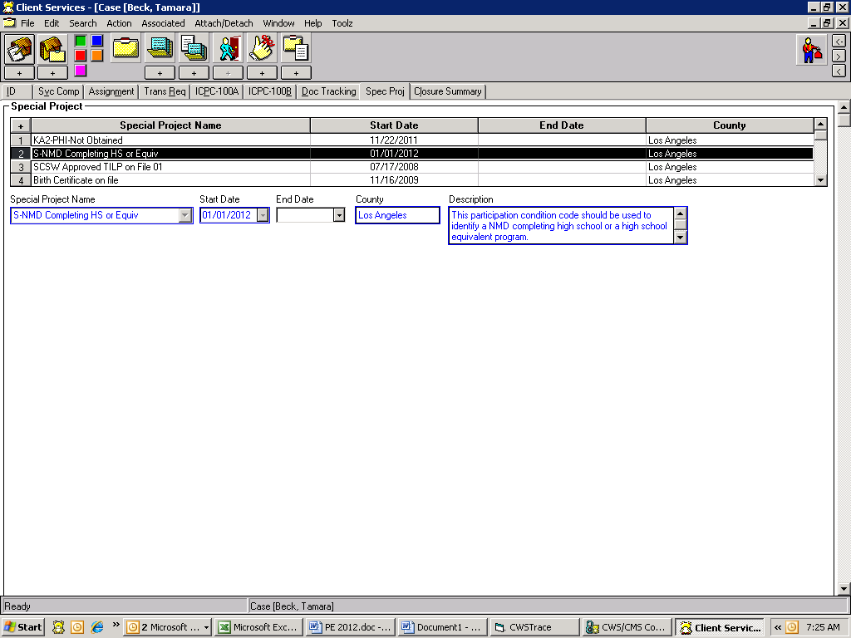

Step 2

Click on the red button, then on the second house “+” sign to the right to create a new placement home.

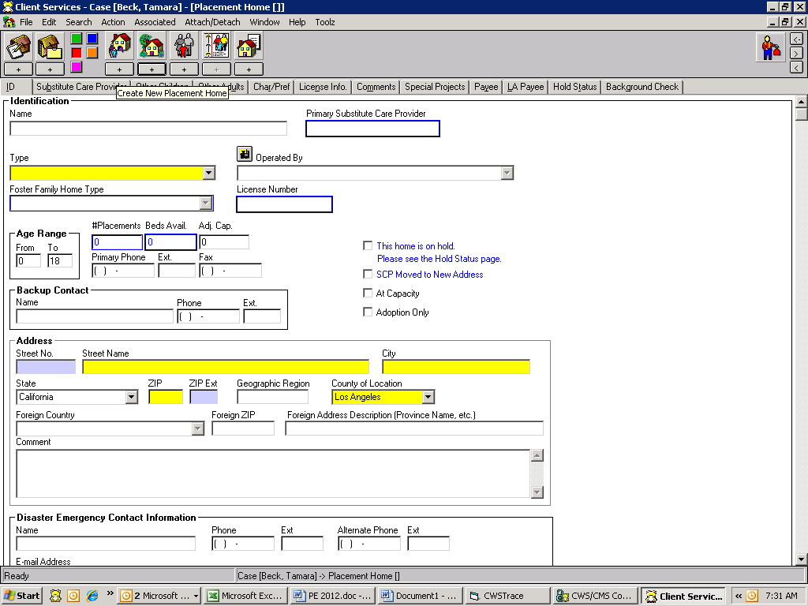

Step 3

You will complete the ID page as usual EXCEPT you must select the Placement Home Type of “Court Specified Home” for SILP placements. (Do not send RM200 to Resource Management for SILP placement). The system will generate the vendor number, however, if after 24 business hours since the placement was created, if you find that the vendor number has not been created, contact the Supervisor over the Resource Management Unit for assistance with setting up the vendor number.

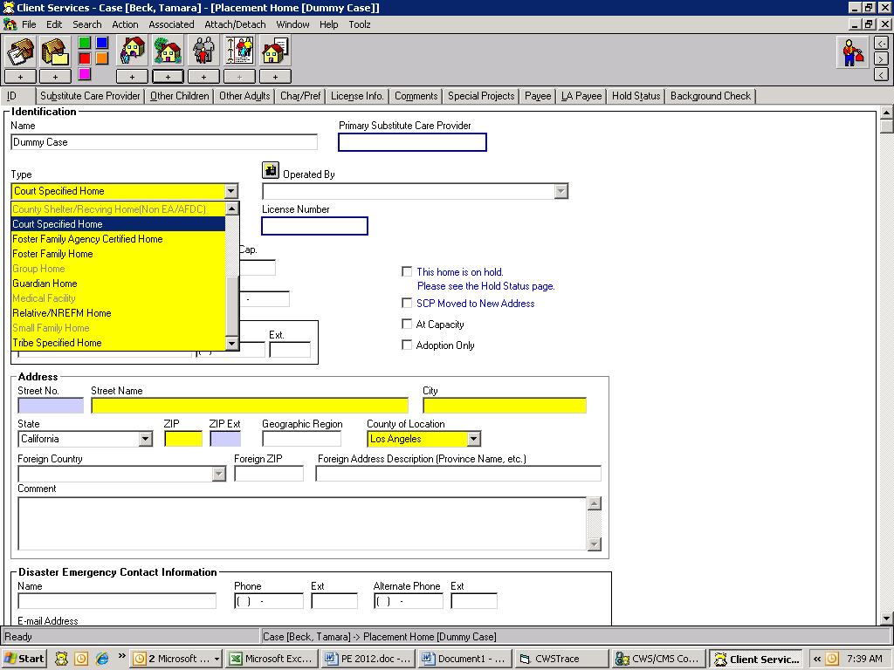

Step 4

Complete the Substitute Care Provider page as usual.

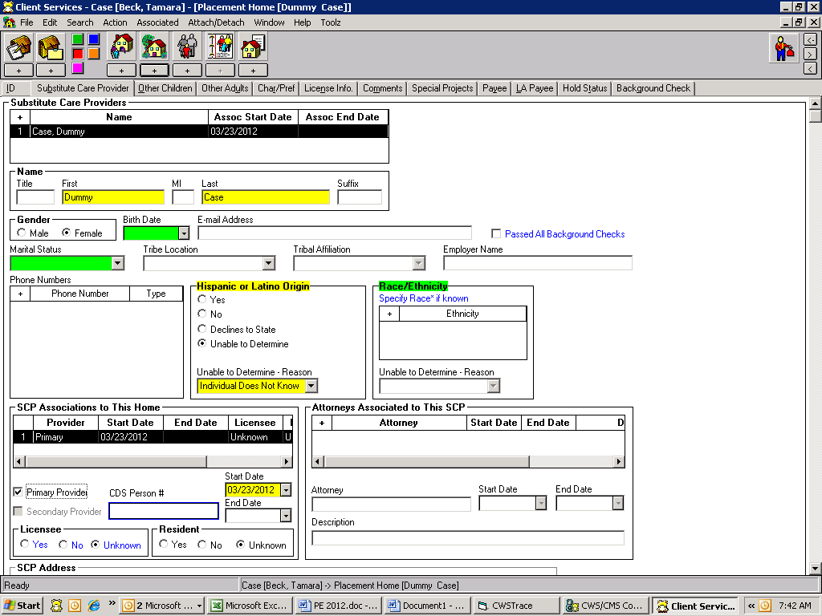

Step 5

Create a Special Project for all SILP placement homes by clicking on the ‘+’ sign and selecting ‘S-NMD SILP’

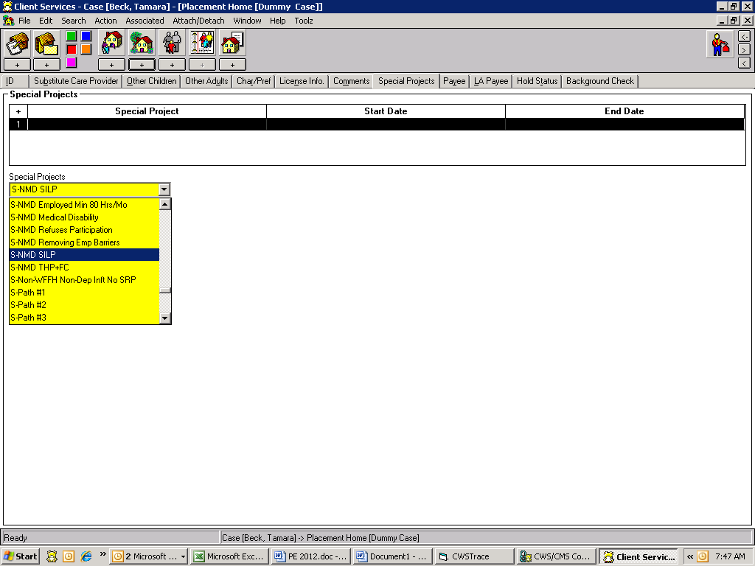

Step 6

Enter the Start Date for the Special Project which should match the Start Date of SILP placement.

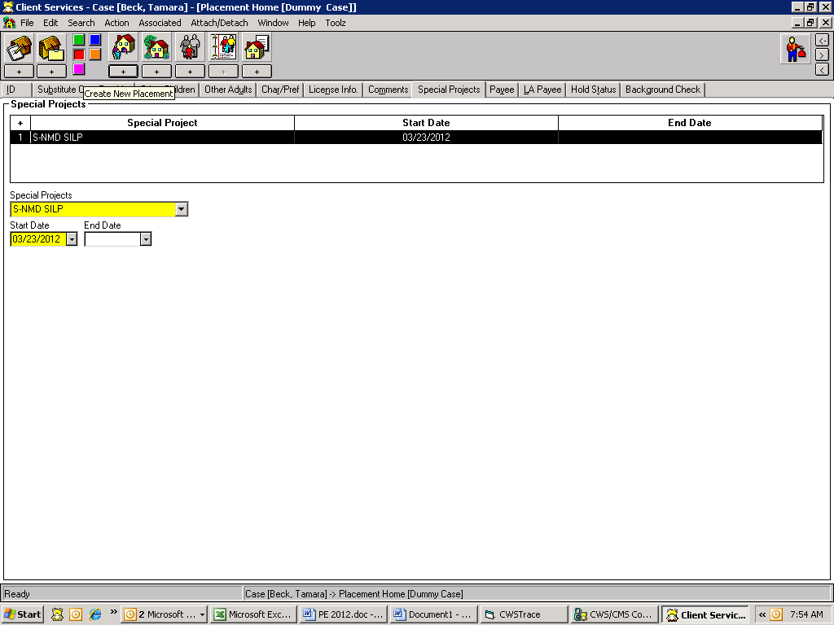

Step 7

Now you have completed adding the home. Click on ‘+’ sign under first house to create placement. Select the SILP home you created and click OK button.

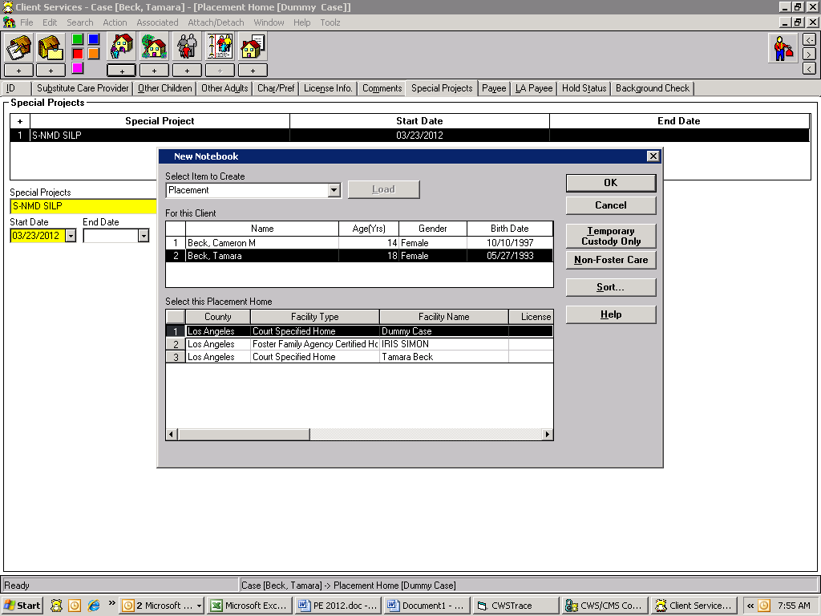

Step 8

ID page on placement, Select “Nonrelatives-Nonguardian” as Care Provider Relationship.

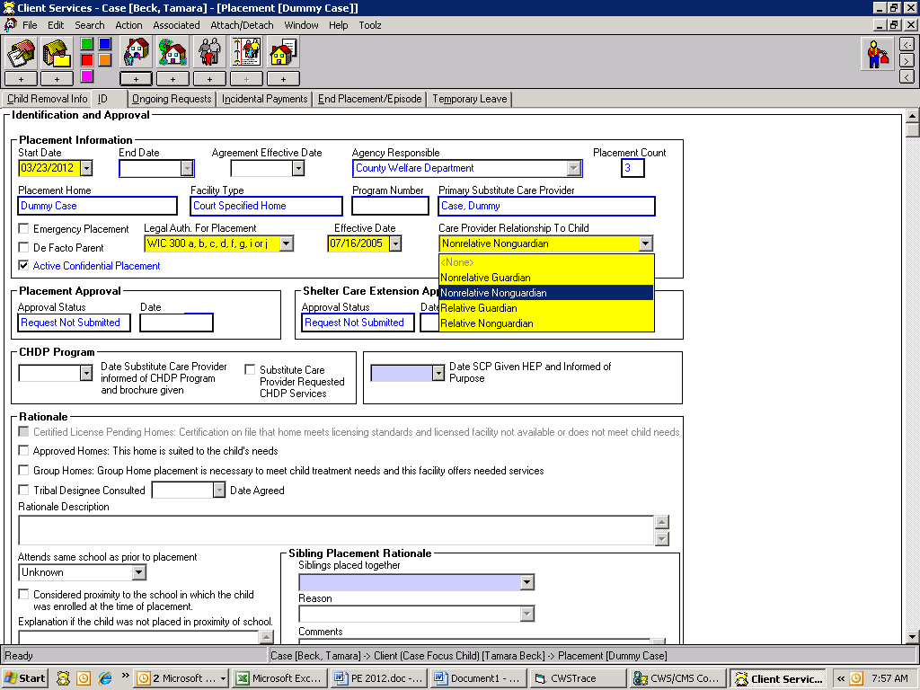

Step 9

Go to the Ongoing Page of placement, Start Date of payment is CSW signature date on SOC 157 A or placement date, which ever comes later. NM (NMD) is eligible for Basic rate only.

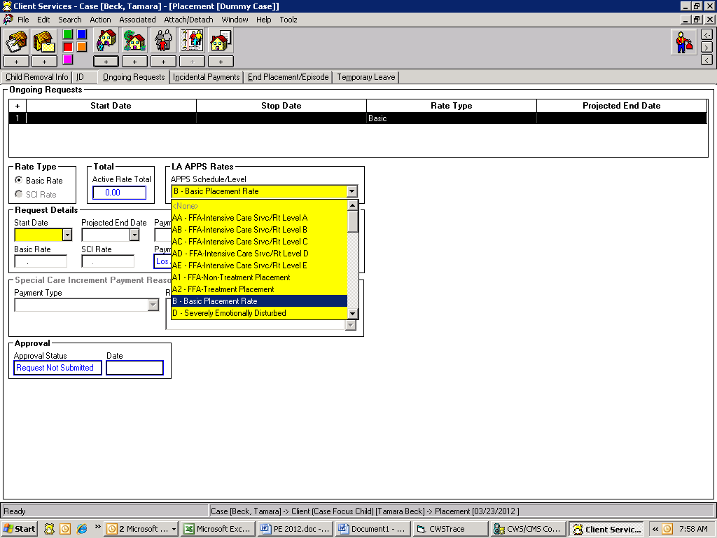

Step 10

The aid code remains the same. (State or Federal).

